Hatton’s monthly village newsletter

Email: [hattonvillage@gmail.com](mailto:hattonvillage@gmail.com)

Website: [www.hattonvillage.co.uk](http://www.hattonvillage.co.uk) for up-to-date news

Facebook –Hatton Village Twitter @HattonVillage

Feb 2016 No. 7



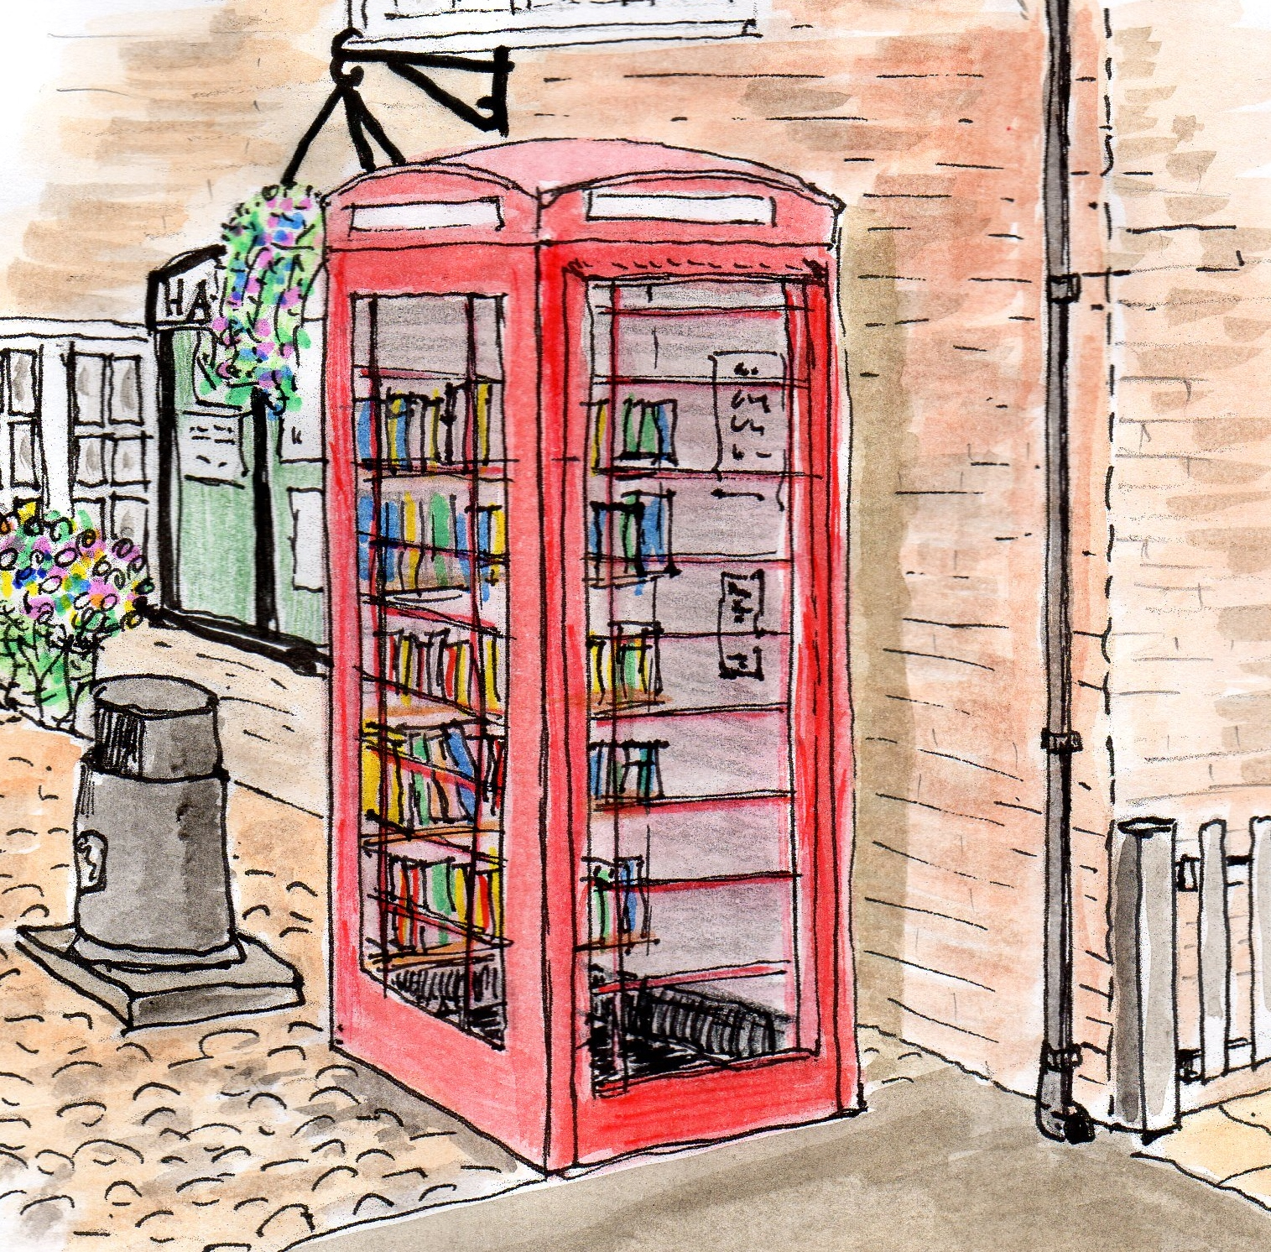

**H**atton **L**ife

**Easter Treasure Hunt Sat 26th Mar 2016 at 2.00pm**

An Easter Treasure Hunt for children aged up to 10yrs is being planned! It will be in and around Goose Lane and Gosling Close, with Easter prizes up for grabs!

The children will be given a list of ‘Easter-themed’ objects to find, which will be visible from the pavements. We want to keep the children – and your gardens – as safe as possible and so we are asking for your help.

We are looking for residents who would be willing for us to place an object i.e. a fluffy rabbit, in their gardens so it can be seen from the roadside. Of course, if you already have an item you could use i.e. a garden ornament, then that would be even better!

If you would like to help give our younger residents a fun-packed afternoon please let us know so we can plan the route and prepare the all important Tick Sheets.

To get in touch please email [hattonvillage@gmail.com](mailto:hattonvillage@gmail.com) (putting ‘Easter TH’ in the subject box) or call Roger on 07871 544500

Thank you, Angela & Roger Dickin

**Hatton sent 40 men to the**

**1914-18 War.**

**Will you "Adopt a Soldier"?**

Daresbury District Heritage Group, meeting regularly over the last year and more, gained a Heritage Lottery Grant to document these men, and a lot of work has been done already. If you are interested in local history, please join us on Tuesday 22 March from 10 a.m. I have invited Sue and Myra from this group to come and tell us over coffee how best to pursue the task. Please let Ron Beever know in advance you will be there, at Jonetti Cottage, Warrington Road (120 yards from the pub) - 01925 730017. You may leave a message.

**HATTON FILM CLUB**

**Spectre ...**Daniel Craig as *007*

**Everyone welcome – and it’s free**!

April – Lady in the Van May - Suffragette

**Hatton joins the 21st Century....**

As the months progress the newsletter will continue to give you all the information you’ve come to expect over the last 7 months. However, to see more extended information on certain topics you can now visit

[www.hattonvillage.co.uk](http://www.hattonvillage.co.uk)

AND you can be kept up to date daily (even hourly) by liking our Facebook page ‘**Hatton Village’** or following us on Twitter **@HattonVillage**



Save a tree...

If you would prefer to receive an email notification to download the newsletter, or view on the website please email us at [hattonvillage@gmail.com](mailto:hattonvillage@gmail.com) and we will make a note not to deliver a paper version of the newsletter to your house.



**Monday 7th March**

**7.30pm**

**Hatton Pub & Grill**

**Free Admission!**

**BT scam**

Be aware... If you have a call from a so called BT Technical support team, suggesting that your internet security has been compromised, and insisting that you log on – DON’T.

Get their telephone number from them (not easy, but insist) and then report to BT.

If the number they give you is 0800 3101045, then it’s definitely a scam.

Don’t be embarrassed about sounding awkward. Do not give information over the phone unless you are sure who you are speaking to.

**POLICE...CAMERA...ACTION...!**

**Hatton Happenings**

**Friday 12th February Theatre Trip to see Shrek the Musical.**

**Monday 15th February 7.30pm**

**Hatton Parish Council** meeting -Lewis Carroll Centre

**Tuesday 16th February 12.30pm**   -  HVCA Residents Lunch. (at Hatton Pub) Will include HVCA AGM. Additional entertainment will be provided

**Wednesday 24th February 7pm**

**Home Watch (& Speeding) meeting with Police at** Lewis Carroll Centre

**Tuesday 22nd March**

**Daresbury District Heritage Group** meeting

**Saturday 26th March 2pm**

**Easter Treasure Hunt**

Goose Lane & Gosling Close

see p1 for more details

**Other events in 2016 to watch out for**:-

HATTS’ON Festival

Hugest Sunflower competition

Hatton’s Hikers

Queen’s 90th birthday picnic

Fun Day Halloween

Coach Trip Carol Singing

A meeting has previously been held between our group (HVPG) and Cheshire Police, and there will be an open meeting at the Lewis Carroll Centre on **24th February 7pm which will be attended by the Police and Crime Commissioner** looking to set up a formal **Home Watch** scheme in Hatton. We need the help of the Village to make this work, but given the recent incidents we hope there will be a vested interest. **Steve Parr, the Police community Support Officer** for Hatton confirmed his attendance at this meeting organised for the 24th February and will be talking about how we set the scheme up.

**Operation Shield** - this is the DNA marking system for equipment in homes that Steve rolled out in the Village last year.  There is going to be an upgrade to this system available soon, that again Steve will be offering to us

**Speeding** - Steve was acutely aware of our concerns around speeding in the village.  He is being trained on the 16th February on True Cam, the latest fully enforceable speed camera.  He can operate this system alone and Steve committed to using the camera at different locations on Hatton Lane and different times of the day once his training is complete.

Steve is happy for traffic "near misses", accidents, erratic driving to be reported direct to him as the Council would always want to know how many such instances had been reported to the Police before considering potential changes to the highways.  In such instances report as much detail as possible to Steve via email [stephen.parr@cheshire.pnn.police.uk](mailto:stephen.parr@cheshire.pnn.police.uk) -it will only help whatever we try to do in the future.

Thanks to the **Hatton Hoofers** who, every month, battle the elements to deliver the newsletters to each and every Hatton resident. Without them (and Nicky at Urban Building Projects for printing) the newsletter wouldn’t have been the success it has been!

**Thank YOU to all of you**

**PARISH COUNCILLOR NEEDED**

Recently Nicky Palmer has regrettably resigned from her role of Parish Councillor and the PC would like to thank Nicky for her valued assistance.

If you are interested in joining the Parish Council and would like to see the type of things we do and discuss, then please look at the minutes /agenda’s/monthly financial statements on [www.hattonvillage.co.uk](http://www.hattonvillage.co.uk). You can learn more by contacting any Parish Councillor or myself on 07947 137 349; at its core the Parish Council is there to represent villager’s views.

To apply to join the Parish Council please email via [clerk@hattonparishcouncil.org.uk](mailto:clerk@hattonparishcouncil.org.uk) giving your main reasons for wishing to join.

Please be aware there may be a Local Election in May, which means that all Councillors representing Hatton may be required to put themselves forward for a local vote.

**Margaret Winstanley Chair Parish Council**

**Margaret Winstanley Chair Hatton Parish Council**

*If you have any comments, suggestions or pictures which could be considered for inclusion on the website or in the newsletter please send to* [*hattonvillage@gmail.com*](mailto:hattonvillage@gmail.com)

Newsletter kindly printed by Urban Building Projects 01925 730888

