**Hatton** Life

hattonvillage@gmail.com

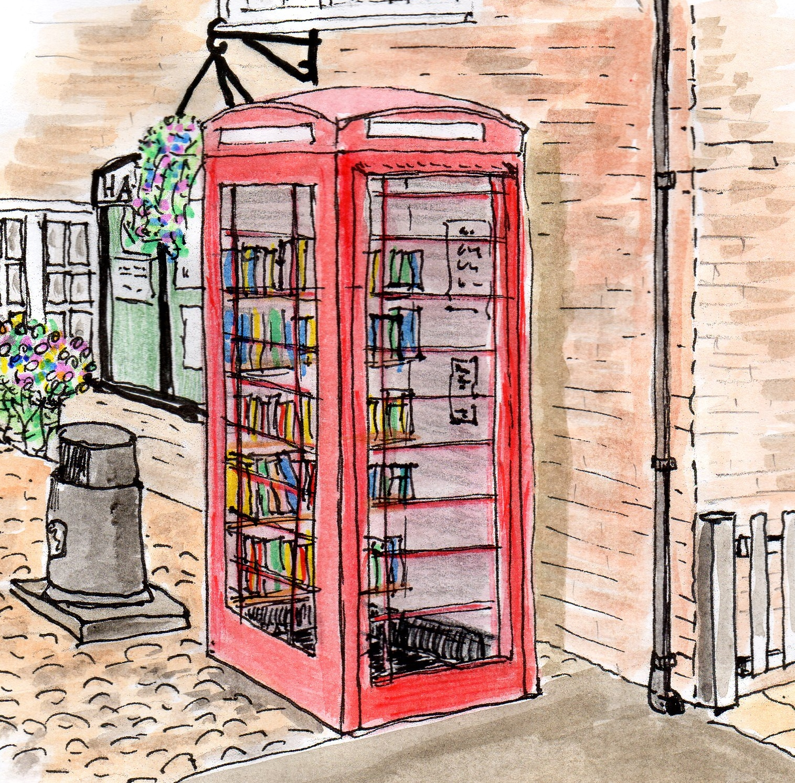

I mage by Robin Brocklehurst

Your monthly newsletter

November 2015 #4

**PROUD OF HATTON? WE SHOULD BE!**

Lots of people help in many different ways to make Hatton what it is! They don’t ask for or expect for thanks or praise. However sometimes it is nice for their work to be recognised. The Parish Council enters Hatton each year to the Community Action Competitions and this year we did really well!

Roger Dickin attended the Cheshire Community Action Awards Evening on behalf of the Parish Council and HVPIG on Thursday 15th October in Ellesmere Port.

**Social**

**Calling all residents**!

**The Community and Social Activity Group** needs ideas and people to join us!

We are a busy bunch with current activities including Halloween, Carol Singing, Manchester trip, Theatre trips, Film Club, Walking Group, Lunches, Fun Day and lots more. New ideas and new faces, of all ages, would be really welcome. Please email [hattonvillage@gmail.com](mailto:hattonvillage@gmail.com) if you are interested.

**Hatton was awarded**:-

* **Runner –Up** In The ***Best Kept Village*** (under 400 population).
* **Highly Commended** in the prestigious ***Community Spirit Award.***
* **Little Gem** for our ***Bus Shelter***.

Congratulations and thanks to everyone!

**Hatton Film Club**

At Hatton Pub and Grill

Monday 7th December

**Earlier start of 7pm**!

**Interstellar**

‘A team of explorers travel through a wormhole in space in an attempt to ensure humanity's survival’

**Everyone Welcome -FREE ADMISSION**

Mince pies, sandwiches & mulled wine, courtesy of Mark & Gina

**Services**

**Home Watch & Road Safety**

There is a meeting with Cheshire Police in early December to discuss the relaunch of the **Home Watch** scheme and the concerns over traffic safety along Hatton Lane.

Watch this space…

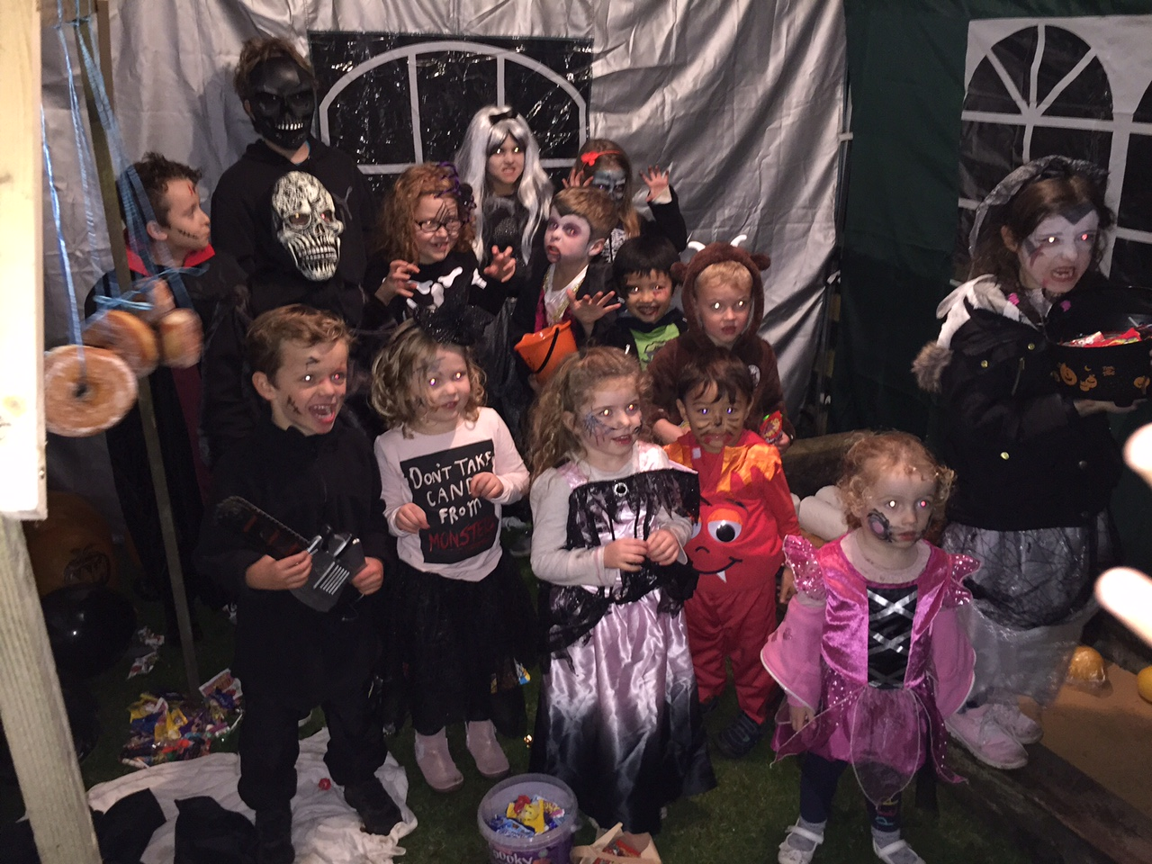

Many people were involved in Hatton's Halloween Celebrations, including 35 terrifying little monsters! Thanks are due to so many people, in particular to Ian and Sylvia for welcoming so many people to their home.

It was such a lovely occasion watching the children have fun by terrorising the village and enjoying themselves with hotdogs and games and was a great opportunity to meet and make friends   for adults and children alike.

You, the villagers, were so generous with the amount of sweets donated and made it very special for the children.

Once again a lovely social occasion for Hatton to enjoy.

**Halloween Happenings in Hatton**

The children waiting for hotdogs after Trick or Treating in the village

**Hatton Happenings**

**Saturday 7th November 7pm**

**The Hatton Guy Fawkes extravaganza**

At Hatton Pub and Grill

Bonfire 7pm. Fireworks 8.30pm. Hotpot dinner. £7 Adults/£3 children inc hotpot

**Sunday 8th November 11am**

**Remembrance Sunday** Laying of a wreath and 2 minutes silence at Hatton’s Remembrance Tree.

**Monday 16th November 7.30pm** **Hatton Parish Council** **Meeting** at the Lewis Carroll Centre. Everybody Welcome

**Tuesday 17th November 12 noon**

**Residents’ Lunch**

Newly appointed PCSO Stephen Parr will be attending to meet residents. Please confirm your attendance to Robin by noon on 15th November on 730030

**Saturday 5th December 2pm**

**Village Trip to Manchester Markets**

2.00- 7.30pm. See below left for details

**Monday 7th December *7.00pm\***

**Hatton Film Club - Interstellar**

Mince pies, sandwiches & mulled wine, courtesy of Mark & Gina, Hatton Pub

**Monday 14th December 6pm**

**Carol Singing** Come and join in with Carol Singing starting 6.00pm at Oak Tree Cottages on Hatton Lane.

(Travel by car to meet if joining us from the centre of Hatton.) Then meet at 6.30pm at Gosling Close Bench. Finishing by the switching on of the Christmas Tree Lights and a song round the tree. All voices and ages welcome!

All proceeds will go to Charity – we raised £100 last year!

**Tuesday 15th December 12 noon**

**Residents’ CHRISTMAS PARTY Lunch-**

Please advise Robin by Sunday13th December 01925 730030. More details next month

**Saturday 26th December**

**Mad Hatters Boxing Day Party** in The Hatton’s Xmas Marquee. *Live Music *Open Mic *Disco *Hot/cold buffet

£10 pre-payment as a donation to the Steve Prescott Foundation

**Environment**

**OCTOBER LITTER PICK AND BULB PLANTING**

A big sincere thank you to the villagers who took part in the recent litter pick and bulb planting. The weather was very kind to us and a significant number of bulbs were planted on the Common. Hopefully Spring will bring a colourful display for us all to enjoy. The really positive news is that we collected 10 bags of litter, down from 41 bags last time.

We now have a regular team of volunteer litter pickers and this result is testimony to their conscientious commitment. Thank you all very much.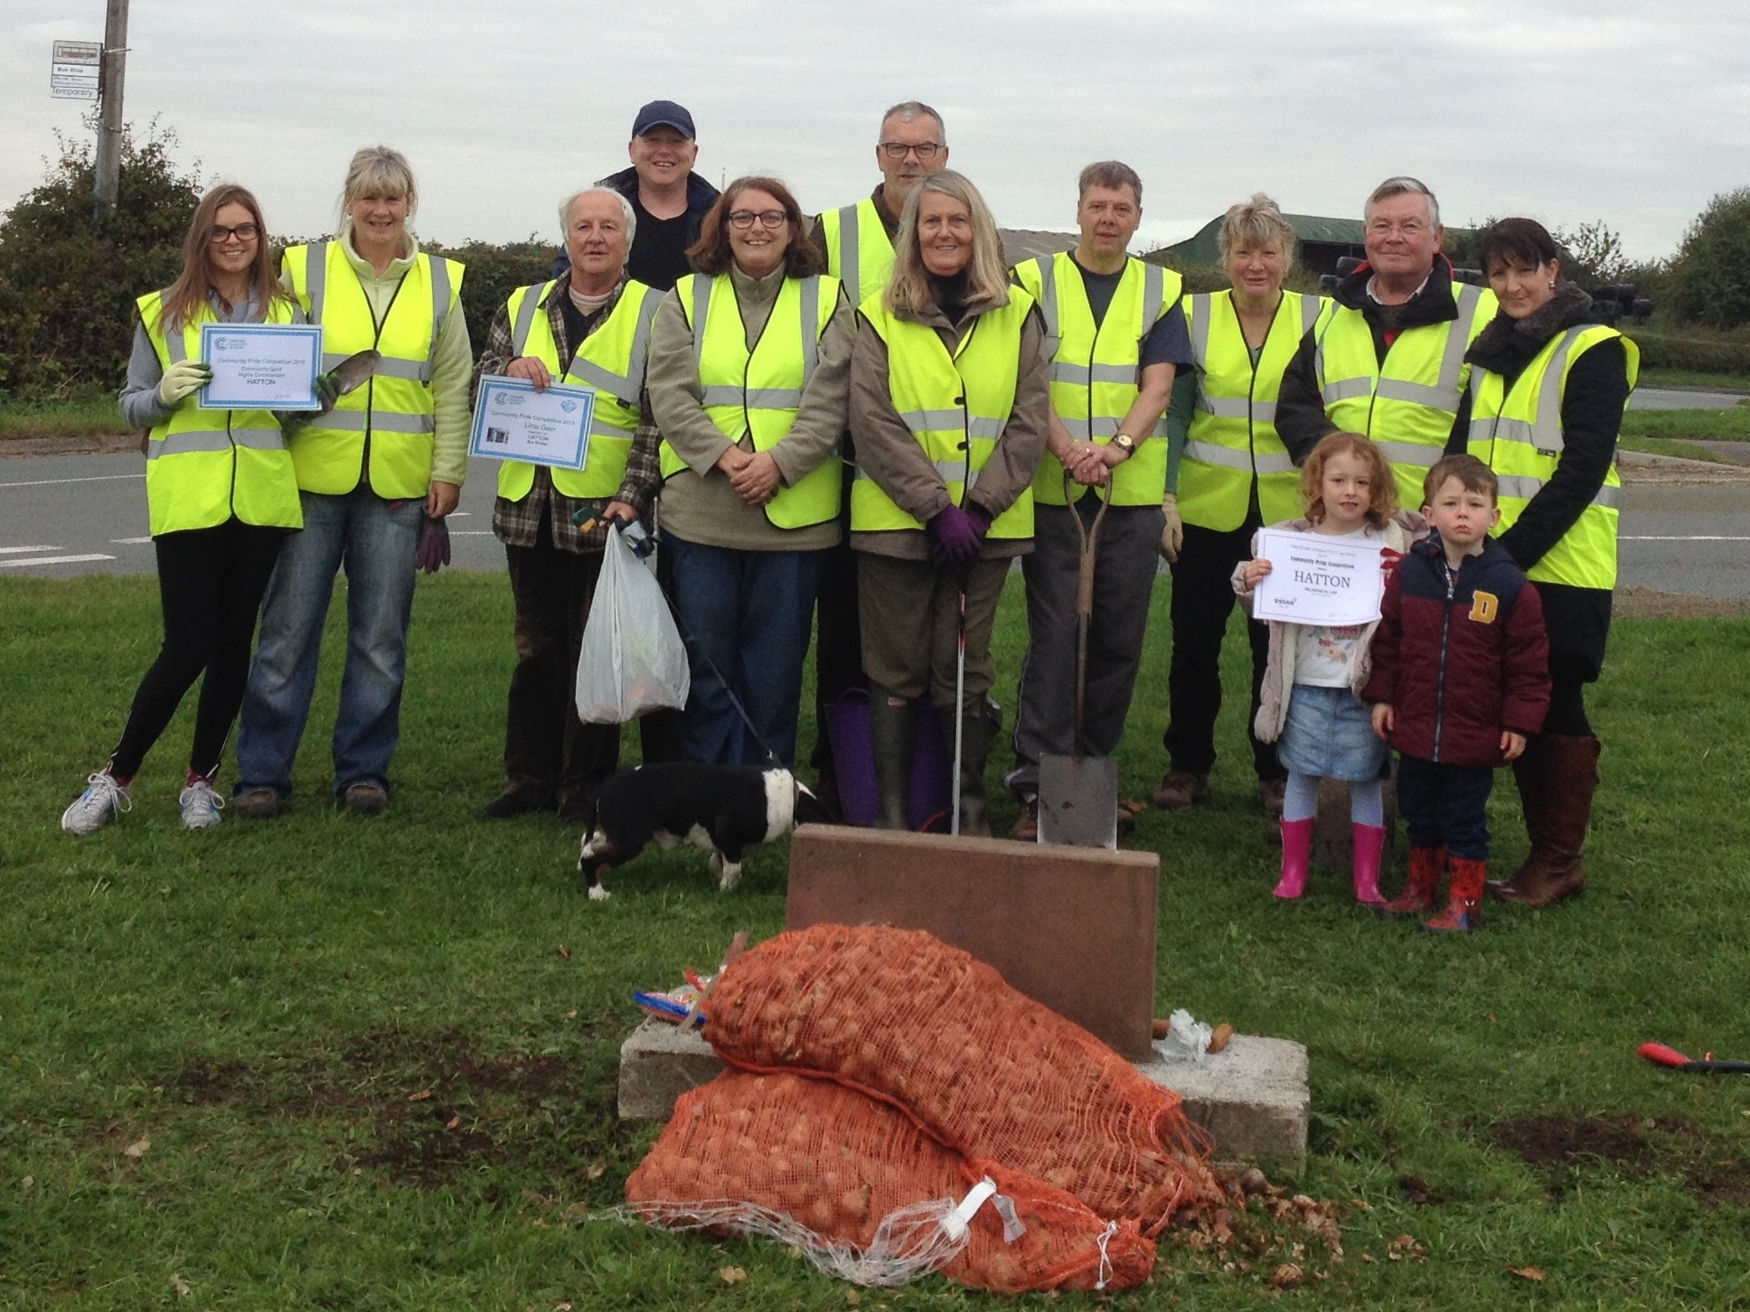

**Hatton Village Community Association.**  
There will be an Extraordinary Meeting of HVCA during the meeting on 17th November to discuss how the HVCA should operate  
in future under the Village Plan Implementation Group and in particular any revisions to the constitution which this may require.  
Robin Brocklehurst

**New website for Hatton**

The all new Hatton Life website is due to go live before Christmas. This is where you will be able to get all things Hatton with the website acting as an extended version of your monthly newsletter.

We are currently collating all the content and will be putting together a Local Business page. If you would like your business listed free on this page please send your business name, contact details and a 10 word description to [hattonvillage@gmail.com](mailto:hattonvillage@gmail.com)

**Services**

**MANCHESTER**

**CHRISTMAS MARKET**

Tickets are still available for our village coach trip to the Manchester Christmas Market

plus any other activities you want to do whilst there. The coach leaves Hatton at 2pm on **Saturday, 5th December**, and returns at 7.30pm. Tickets cost £3 for adults and £2 for children.

Please ring Margaret Winstanley on 730029 or Judith Godley on 730509.

A number of residents have expressed an interest in setting up a **bulk buying scheme** for **LPG and heating oil**. With winter upon us, please get in touch at if you would like to join the scheme.

We are looking at obtaining a group discount if a number of **septic tanks** can be emptied in one tanker visit. If this is of interest, please contact

hattonvillage@gmail.com

Newsletter kindly printed by Urban Building Projects ltd

01925 730888

