**Hatton** Life

By Robin Brocklehurst

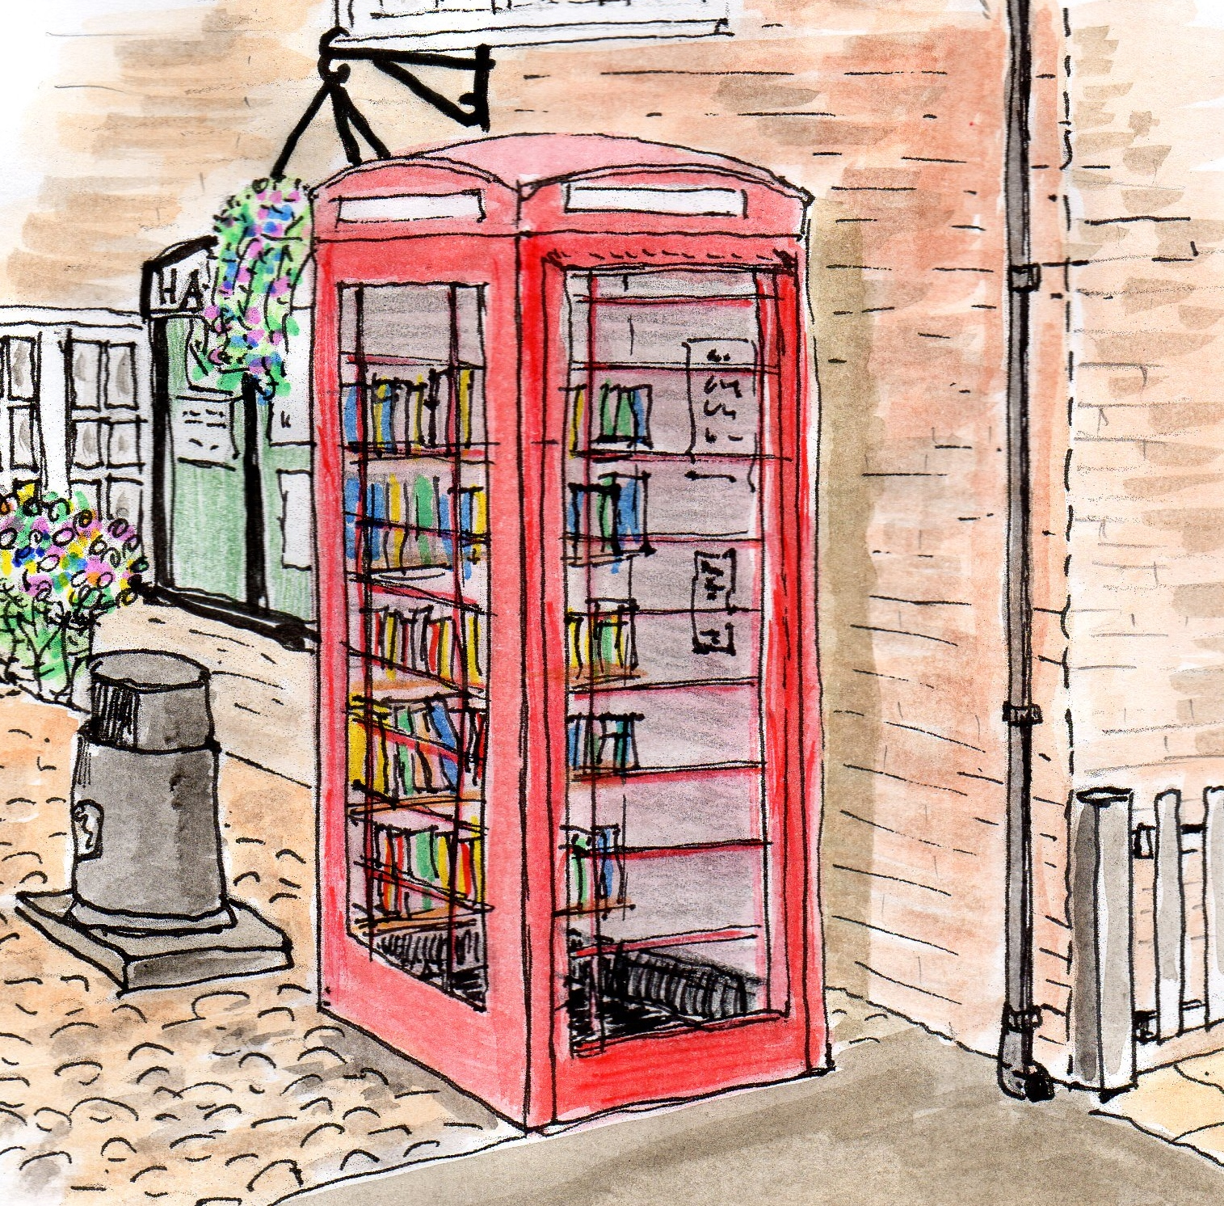

Your monthly newsletter

**September 2015 #2**

**Environment**

**Bird nesting boxes**

A number of bird nesting boxes have been purchased with the intention of placing some in public areas throughout the village, and offering others to children who wish to have one in their own gardens encouraging birds to nest.

If your child would like one (no charge, just an adult in the house to position it) then please contact Judith Godley on [judith@judygodley.plus.com](mailto:judith@judygodley.plus.com) to arrange a convenient pick up time.



**Keeping Hatton Litter Free**

A big thank you to those who have volunteered to undertake regular litter picking in their immediate area. Two safe walking routes remain not covered; one from the Sankey Lane road sign (near the three flower tubs) to the motorway; the other down Hatton Lane along the footpaths. Please if you feel able to undertake any litter picking in any part of these areas contact Judith Godley on [judith@judygodley.plus.com](mailto:judith@judygodley.plus.com) or Margaret Winstanley on [mwinstanley21@gmail.com](mailto:mwinstanley21@gmail.com). A full village litter pick and bulb planting will take place on **Saturday, 17th October**. Meet at the bench opposite the Hatton at 10am. Bin bags and high viz jackets will be provided. Please come along to help so we can continue to improve our environment.

**Village Voice**

**SPEED AWARENESS**

This is a plea to drivers using the village either as a cut through or for everyday getting about. Please be aware of the speed you are travelling and the impact that exceeding the speed limit has on other villagers, particularly those who live on Hatton Lane and who have to endure both high volumes and speeding daily traffic.

Walking and living along the end of Hatton Lane where there are no footpaths can be dangerous and unpleasant as it’s often difficult to throw yourself onto the grass verges in enough time to avoid the speeding, close cars. Overtaking seems to be a frequent pastime recently of many drivers who simply can’t bear to drive at the official speed limits.

If Hatton residents were to adhere to the speed limits this could be a start to slowing all through traffic down and making Hatton Lane a safer place to live. Please, please be aware of your speed. **Hatton Lane Villager**

***Dear Hatton Lane Resident***

*A dialogue has commenced with Stretton PC on how they financed their electronic sign, how and by whom it was sighted and how effective they believe it to be. At Lower Stretton they have two hard traffic calming methods. Hatton Villagers ‘spoke’ through the plan and speed bumps and similar were unpopular. It may be however that these sorts of restrictions are the only truly effective ones. Meanwhile, if anyone witnesses significant excess speed then they should make a note of the registration, time, estimated speed and the direction of travel and report through to the neighbourhood police contact Dave Mahon at Stockton Heath Police Station.*

***Transport Team, Implementation Group***

Wildflowers on the Common, sown by volunteers in early spring

**Services**

**Home Watch**

A number of people expressed interest in reforming the **Home** **Watch** scheme. We are now assessing the feasibility of introducing a new scheme, and ask that all those who are interested, please contact us at [hattonvillage@gmail.com](mailto:hattonvillage@gmail.com).

The more people that get involved, the more effective the scheme will be, for the benefit of everyone in Hatton.

**Parish Council**

**Creamfields Comments**   
Please send any feedback which you would like to become part of the community/organisers/ police debrief session in October    to [mwinstanley21@gmail.com](mailto:mwinstanley21@gmail.com) Hatton Parish Council

Any comments, topics for discussion or photos which you feel could be considered for inclusion in the newsletter please send to [hattonvillage@gmail.com](mailto:hattonvillage@gmail.com).

Deadline last Friday of the month.