Hatton Life
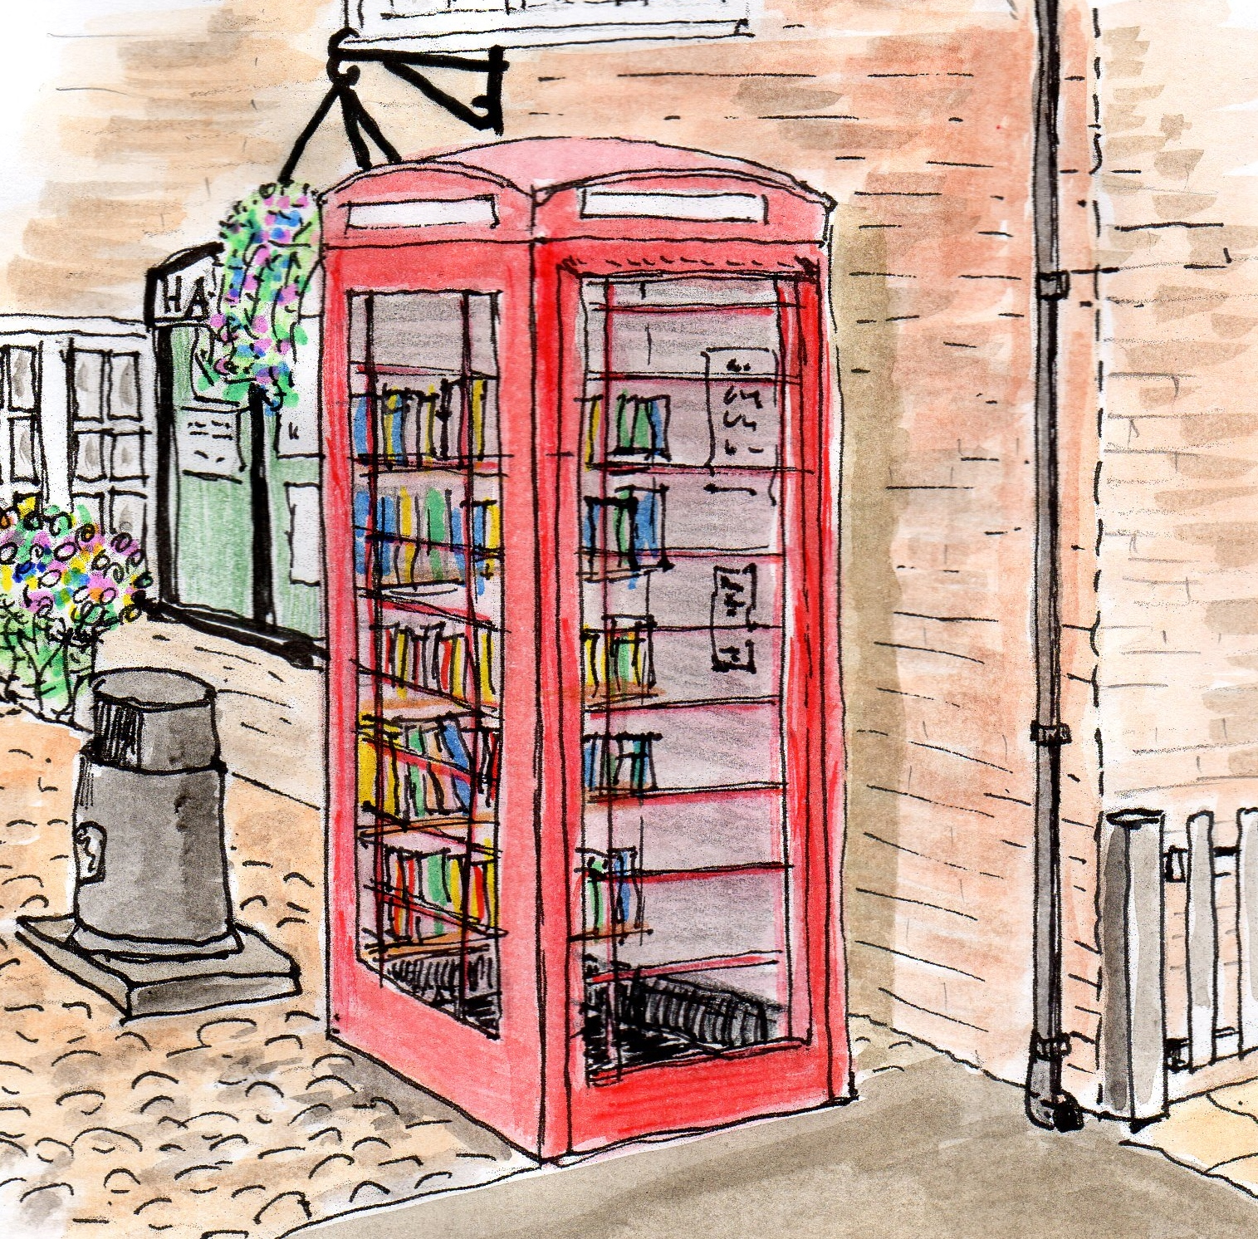
Your monthly newsletter

August 2015 #1 Illustration by Robin Brocklehurst
Transport
The Bus is back
Network Warrington has agreed to reinstate the 9.30 and midday bus to/from Hatton.

Service 8 arriving Hatton 0933hrs.
From Hatton at 0936hrs
Additional service 9 at 1205hrs Warrington – Hatton, arriving 1230hrs
Service 9 1233hrs Hatton – Warrington, arriving 1302hrs
Monday to Friday. Starts 1st September and will be reviewed

Social
Hello and Welcome to our first ever Monthly Newsletter: about Hatton for the people of Hatton.
The Village Plan highlighted your wish for a single way of letting us know what’s going on and what’s planned in the Village.
Thanks to those who have made this newsletter happen – please do let us know how we are doing!

Roger Dickin: Chair - Implementation Group.

Use it or lose it
Photo courtesy of Hatton Pub & Grill

Fun in the Sun
A great day was had by all at the Hatton Fun Day back in July. Surprisingly the sun shone, and thanks to the generosity of all those who attended, donated their time and energy or donated in other ways it raised £750 for charities and Village projects.
We were kept so busy that we didn’t get the chance to take many photographs. If you have a photo that you would like the rest of Hatton to see please do send them to us at hattonvillage@gmail.com. They will be included on our NEW website, which is currently being developed.

Any comments, topics for discussion or photos which you feel could be considered for inclusion in the newsletter please send to hattonvillage@gmail.com.
Deadline last Friday of month

Hatton Film Club
At Hatton Pub & Grill
Coming Soon- Mon 7th Sept 7.30

DARK HORSE

Dark Horse tells the extraordinary true story of how, on her allotment, a barmaid from South Wales bred a racehorse that became a champion.

Find out more about this award-winning documentary, the range of colourful characters involved, the sport of kings in general and other classic movies about horses and underdogs.
Only just out on DVD – 10th AUGUST!
Not to be confused with films of similar names.

Everyone welcome

This is Hatton’s Film Club, for you, a Hatton resident and your friends and family.

FREE ADMISSION

