**Hatton Happenings**

**Saturday 12th September**

**Hatton & District Show.** Marquees open 1.30pm

**Tuesday 15th September 12 noon**

**Residents’ Lunch-** Talk on ‘**Bees and Plants’** by Stuart Hatton. At Hatton Pub & Grill.

**Monday 28th September 7.30pm**

**Parish Council Meeting** at the Lewis Carroll Centre.

**Monday 5th October 7.30pm**

**Hatton Film Club – Kingsman: The Secret Service**

At Hatton Pub & Grill

**Saturday 17th October 10am**

**Litter Pick and Bulb** **Planting** Meet at bench opposite Hatton Pub & Grill

**Saturday 31st October 6pm**

**Trick or Treat -** followed by **Hot Dogs** and drinks for the children, funded by the Parish Council, at Branscombe, Warrington Rd. Hatton. Meet at 6.00pm at the entrance to Gosling Close. Parents must supervise children at all times.

**Saturday 5th December 2pm**

**Manchester Christmas Markets**. Leave Hatton at 2pm. Depart Manchester 7pm

**Monday 14th December Time tbc**

**Carol singing -** This year **Hatton Lane** will be included in the Carol Singing route.

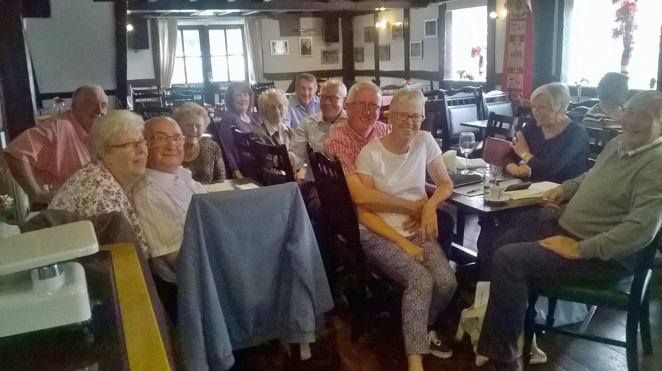

Following a short summer break the **Community Association's Residents** Lunches kicked off again on 18th August when 20 residents and 2 guests enjoyed a fabulous lunch at the Hatton Pub & Grill.  
The occasion allowed the residents to remember the 'old Hatton' village and to share many humorous anecdotes of times gone by. It was a very enjoyable occasion.  
The next lunch is on 15th September when Stuart Hatton will talk about "Bees and Plants". As usual everyone is welcome to join the party.

**Diary**

**Social**

**Ward Boundary Review - Have your say by 19th October.**  
**The Boundary Commission** has produced its recommendation for Warrington. They would like to hear the opinions of residents by **October 19th** at the latest.  
Their recommendation is that the Ward of Hatton, Stretton and Walton will no longer exist and Hatton will become part of the Borough Ward of Appleton.

To read details and to have your say online:[www.warrington.gov.uk](http://www.warrington.gov.uk), follow the link on left for **Council Democracy and Elections**, and then the **Consultatio**n Icon, scroll down till you reach **External Consultations** and then click on **Electoral Ward and Boundary Review**. The details and links are all there.  
**Use the opportunity to Have Your Say**!  
This item will be on the agenda for the Parish Council meeting on 28th September

**Hatton Film Club**

At Hatton Pub & Grill

Monday 5th October 7.30pm

**K i n g s m a n**:

The Secret Service

A spy organisation recruits an unrefined, but promising street kid into the agency’s ultra competitive training programme, just as a global threat emerges from a twisted tech genius

***Starring***

***Colin Firth, Taron Egerton, Samuel L Jackson***

**Everyone welcome**

This is Hatton’s Film Club, for you, a Hatton resident and your friends and family.

**FREE ADMISSION**

**Services**

**DOWN THE DRAIN**

After reviewing the location of properties on private drainage and their proximity to public sewers, it is unfortunately not financially viable to provide mains connections.

However, it has been suggested that we investigate a group discount for those on **private septic tanks.** Please contact[hattonvillage@gmail.com](mailto:hattonvillage@gmail.com) if you would be interested in such a scheme.

**Parish Council**



Newsletter kindly printed by Urban Build Projects Ltd