Margaret Winstanley – Chair
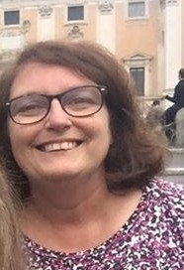
I have loved living in Hatton for over 28 years. My two daughters were both born and raised here. Having had the benefit of such a wonderful setting , incredibly friendly people and great community spirit I decided I would like to give back in a small way and joined the Parish Council over 15 years ago. I am currently Chair of the PC and take my duties of being part of a team who act as caretakers of our village, both now and for future generations, very seriously.. Hatton is an incredibly active village and I am proud of my work over the years including within the Village Plan team.
I particularly enjoy helping to organise Hatton Village Plan events eg Fun Day , Carol Singing, village trips, Halloween and much more. I am a member of the Village Plan Communications team, the Environment team and am part of the Village Hall Feasibility Study group. I represent Hatton on the WBC Warrington South Neighbourhood Board to ensure our views are heard and can be taken into account. Most importantly I believe everybody should have a say in making decisions that effect our village and enjoy working to represent villagers wishes, including the young members of our community. Working at Appleton College, part of Bridgewater High means I have the privilege of working with college students. I am particularly proud of introducing the opportunity for the Youth of Hatton to be represented on the Parish Council for the last 4 years. They too deserve a say!
We have a great environment and should not be complacent and continue to work to make Hatton an even better place to live.
Roger Dickin – Vice Chair
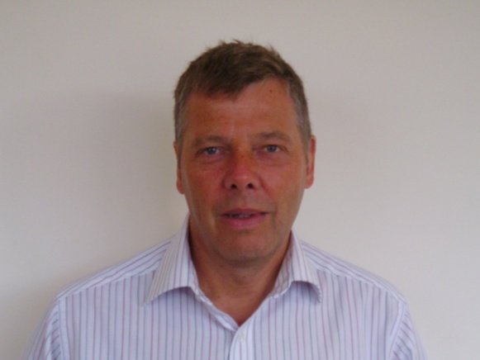
I joined the Parish Council in May 2015, having served as Chair for the Hatton Village Plan Steering Group. I now Chair the Implementation Group, which is working so hard to deliver the Actions in our Village Plan. I'm married to Angela and we moved into the village in 2009, with our 2 dogs! We both really value the community spirit in Hatton and by being involved with the Parish Council, I hope I can maintain our village life for future generations.

Julian Wrigley – Planning
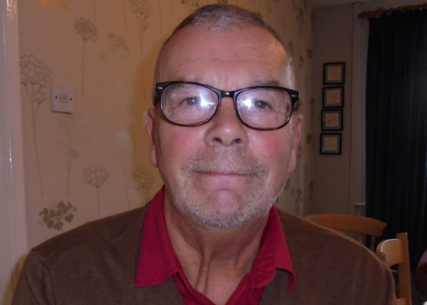
I have lived in the village for 45 years and been a member of the Parish Council for longer than I care to remember. I have been Chairman twice and am currently the member responsible for Planning. I am also Secretary of HVCA.
Stuart Tranter - IT
I have lived in Hatton with my wife Sue since 1999 and joined the Parish Council in September 2015. Although now retired I have an IT background so have this primary role within the PC along with anything else I can assist with.

Judith Godley - Finance

I have lived in the village for over 22 years. Retirement in late 2010 gave me the time and opportunities to become actively involve in village life. In March 2012 I became the Treasurer of the Hatton Village Community Association (HVCA), a position I held until December, 2015.

I joined the Parish Council in July, 2012, and have responsibility for the scrutiny of the finances.
When the Parish Council commissioned the production of a Village Plan in 2013 I joined the group that became responsible for its production writing the Environment Section.

I thought my work was done when the Hatton Plan was published but found myself on the Implementation Group chairing the Environment Group. I am also the Treasurer for the Hatton Plan.

Amber Smith – Youth Representative
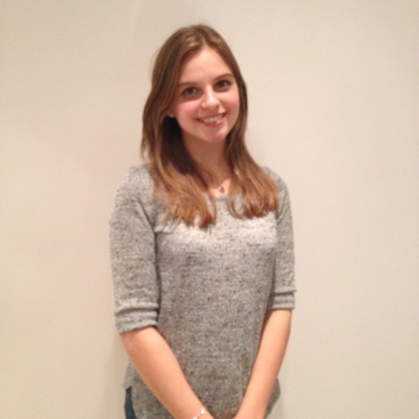
My name is Amber Smith. I have lived in Hatton since 1999 and I joined Hatton Parish Council in 2014 to give a voice to the youth of the village. Over the years I have enjoyed the interaction the role brings, particularly participating in village events such as litter picking, flower planting and instigating a village outing to Shrek the Musical. It's great to live in such a close-knit village and be part of such a wonderful team!

