***In your September newsletter*: - Big transport and road safety news; Film Club’s latest showing; Open Residents’ meeting; Creamfields info; Tallest Sunflower winner; Diary dates**



Hatton Life



Issue No 14 September 2016

Email:hattonvillage@gmail.co.uk

**H A T T O N**

**F I L M C L U B**

**Following on from our news last month that the introduction of a weight restriction on the roads of Hatton had been legally approved we have further good news.**  
A second proposal reducing the speed limits on certain of the roads in the village has also passed through legal process without objection and will be implemented in due course.  
  
  
1. Entering Hatton from the traffic lights at the Cat and Lion the 30mph speed limit on Hatton Lane will extend past Lynton Day Nursery and end at the little S bend by the house Glenfield.  
2. The speed limit on the length of Pillmoss Lane will reduce from the current National Speed Limit to 40mph.  
3. The 30mph limit on entering the village on Hatton Lane will be extended and start near the bend next to Rowswood Timber Supplies.  
4. The speed limit on Daresbury Lane from the Hatton end will reduce from the National Speed Limit to 40mph up to the boundary with Halton.  
  
**These introductions will reduce HGV traffic through our village and also hopefully reduce the speed of traffic and improve safety.**

We must thank Jamie Fisher the Principal Highway Engineer at Warrington Borough Council for his positive assistance in this matter.  Now everything has been approved Jamie's team will complete all the necessary paperwork and appoint a contractor.  Once we know the start date for implementation we will let you know.

**TRANSPORT UPDATE AND ROAD SAFETY UPDATE**

**Monday 5th Sept 7.30**

At Hatton Pub & Grill

Featuring

**Eddie**

**The Eagle**

**All Hatton residents, their friends & family are welcome**

**Entrance is FREE!**

**WHAT WILL CHANGE?**

**T I N Y T A L L E S T**

**S U N F L O W E R**

**W I N N E R**

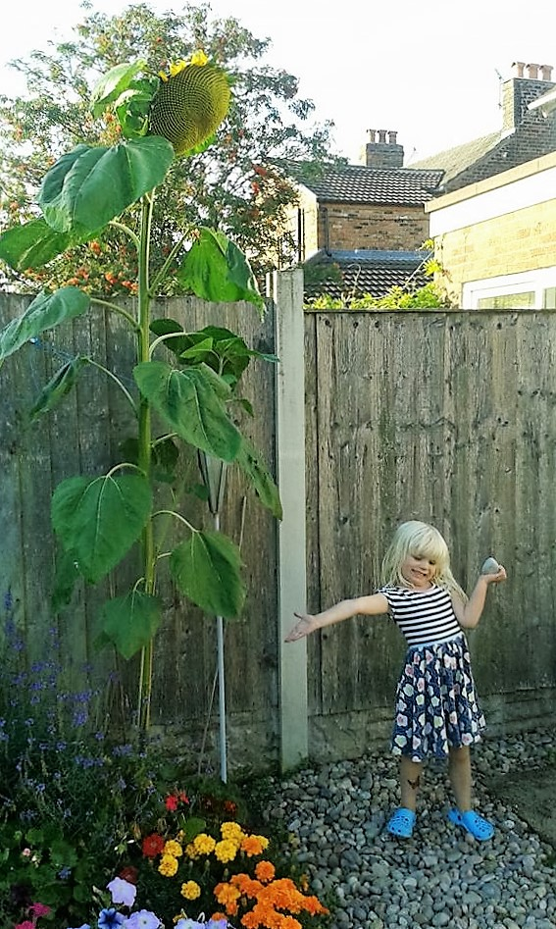

**Congratulations to Elizabeth Burrows of Rivendell**

**for her incredibly tall sunflower!**

Grown from seed by Ian Tickle, children in the village were given young plants and set about attending their every need to try to grow the hugest of Hatton’s Sunflowers.

Elizabeth's Sunflower has reached the dizzy heights of 236cm! Second place measured a healthy 190cm.

The winner’s prize was a gardening set.

Well done to all competitors.

[**www.hattonvillage.co.uk**](http://www.hattonvillage.co.uk) **Your one stop shop for all things Hatton**

[**www.hattonvillage.co.uk**](http://www.hattonvillage.co.uk)

You’ll find everything that’s here in your newsletter and so much more including:-

* *Local information*
* *Hatton Walks*
* *History*
* *Recommended Trades People*
* *Local Businesses*
* *An Insight into the work of*
* *the Parish Council*
* *News of the Hatton Village Plan Implementation Group’s progress*
* *Event Calendar*

....and much, much more

**HAVE YOU VISITED**

**YOUR VILLAGE WEBSITE RECENTLY**?



Newsletter kindly printed by

**Urban Building Projects**

01925 730888

Warrington BC is currently going for round 2 funding with the Heritage Lottery Fund to restore the glasshouses at **Walton Hall**. If you have a view on this please fill in the survey at <https://www.warrington.gov.uk/waltongardens>. You could be in with a chance of winning £50 of high street vouchers!

This year the main stages will be running:  
Friday 26th August        3pm to 11pm  
Saturday 27th August    2pm to 11pm  
Sunday 28th August     12pm to 11pm  
Road restrictions will be in place from morning of Thursday 25th August when the campsites will be opened. The Parish Council have met and communicated with Festival organisers to try to help mitigate the effects of the festival on Hatton. Agreements have been reached on addition of village centre and Pillmoss Lane stewards and reinstatement of a tower on Warrington Road. Discussions are continuing.  
RESIDENTS  Hotline: 0333 321 3129 will be open during office hours from  August 15th and open 24hours from Thursday 25th until 4.00pm on Monday. 29th August. Email: [creamfields.resident@livenation.co.uk](mailto:creamfields.resident@livenation.co.uk)

**If you have any issues post event, such as clean up, traffic etc, which you feel need to be followed up by the Parish Council then please email** [**hattonvillage@gmail.com**](mailto:hattonvillage@gmail.com)**. Your comments will be forwarded to the Parish Council to collate on behalf of residents for debrief and future year’s actions.**

**Creamfields Summer 2016**



**HATTON**

**HAPPENINGS**

**Monday 5th September**

**Hatton Film Club** 7.30 at Hatton Pub & Grill featuring **Eddie the Eagle**

**Monday 19th September**

**Parish Council** **Meeting**.  7.30pm Lewis Carroll Centre Daresbury . All welcome and opportunity for residents to raise any issues from 7.30 to 7.45pm. Minutes and agendas can be found at hattonvillage.co.uk.

**Tuesday 20th September**

**Residents’ Lunch** at Hatton Pub & Grill. Speaker to be confirmed. Please confirm attendance to Robin by 5.00 pm on Sunday 18th September.

**Tuesday 27th September** 7.30 at Hatton Pub & Grill

**Village Open Meeting**. A FREE drink for all who attend, courtesy of the Parish Council. See above article for more details

Events later in the year (dates to be confirmed)

**September** – A **Walking Treasure Hunt**

**October** - Hatton’s **Halloween** Happenings

**November**- **Christmas Coach trip** –

**December** – **Carol Singing**.

If you have any comments, news, or suggestions you’d like to share with us then email [hattonvillage@gmail.com](mailto:hattonvillage@gmail.com). We’d love to hear from you....!

**Once again, the Parish Council will be delighted to give all those attending a free drink! So get there early!**



**Village Open Meeting Tues 27th September at 7.30pm**

In the Hatton Bar & Grill

Remember our Open Evening in May 2013?

The evening was standing room only and saw the start of our Village Plan.

The Parish Council now invite you to a similar evening where important issues in village life including Speeding and the Internet will be discussed.

