***In your November newsletter*: Residents’ Theatre Trip; Hatton Happenings; Halloween Horrors; Film Night; Cheshire Community Action awards; Village Open meeting; Speeding concerns; Liverpool Day Out**

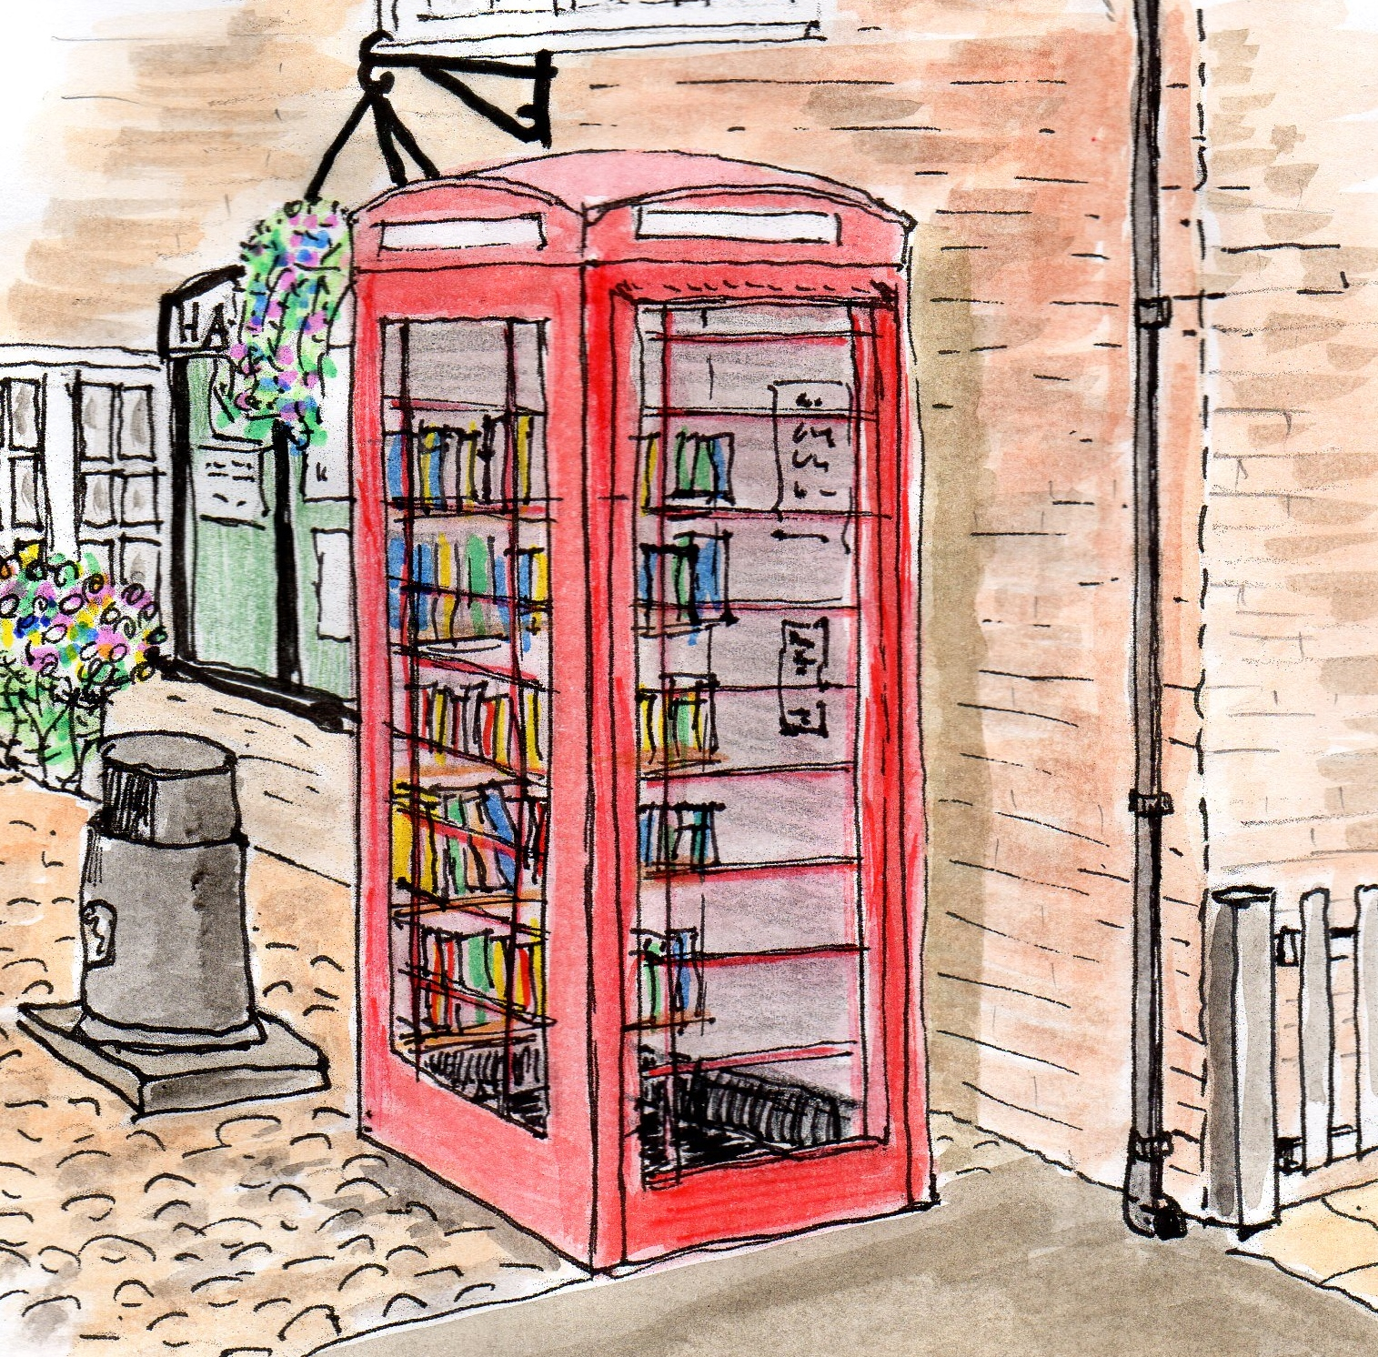

Hatton Life



Email:hattonvillage@gmail.co.uk

www.hattonvillage.co.uk

**Issue No 16 November 2016 October202016**

The **VILLAGE MEETING**, organised by the **Parish Council,** brought villagers together to learn about the work done over the past 12 months by the **Hatton Village Plan Implementation Group.**

It also gave an opportunity for those present to share their thoughts on how village life here in Hatton could be even better! The evening attracted some 40 or so villagers, who heard from members of the Group whilst enjoying a drink provided by the Parish Council.

After a welcome from **Margaret Winstanley**, Chair of Hatton PC, **Roger Dickin** introduced the Implementation Team, who gave a review of their activities and brought to life their many successes. The Groups work resulted in over **100 actions** being successfully completed within just 12 months – great work by the teams and all those villagers who have helped in any way to deliver our Village Plan. Roger also gave an update on the broadband levels we receive and explained that a feasibility group had been looking at planning considerations should we wish to consider a community building in the future. The residents then shared their ideas on additional improvements we can make –see **hattonvillage.co.uk/news.** All the ideas raised will be communicated to the village and then considered by the Group for action. To see full details of the evening visit hattonvillage.co.uk/news

**Hatton’s a Winner….!**

**In the year when our Olympians have again exceeded expectations, our own Village has achieved personal bests, gaining two Golds and a Silver!!**

Hatton received fantastic recognition at the **Cheshire Community Action** awards in Sandbach on Thursday 13th October. We were presented with the following awards:

**WINNER of BEST KEPT VILLAGE (under 400)**

**WINNER of BEST COMMUNITY WEBSITE**

**HIGHLY COMMENDED for COMMUNITY SPIRIT**

Members of the Parish Council were delighted to receive these accolades

on behalf of the whole village.

**Huge thanks  and massive congratulations to all those who have worked so hard to keep our village looking as good as it possibly can do; to all those who contribute to and use the website and to the community minded residents who think of the people as well as the place….!**

**The awards have been placed in the Village Noticeboard until moving to their permanent home- please do have a look!**

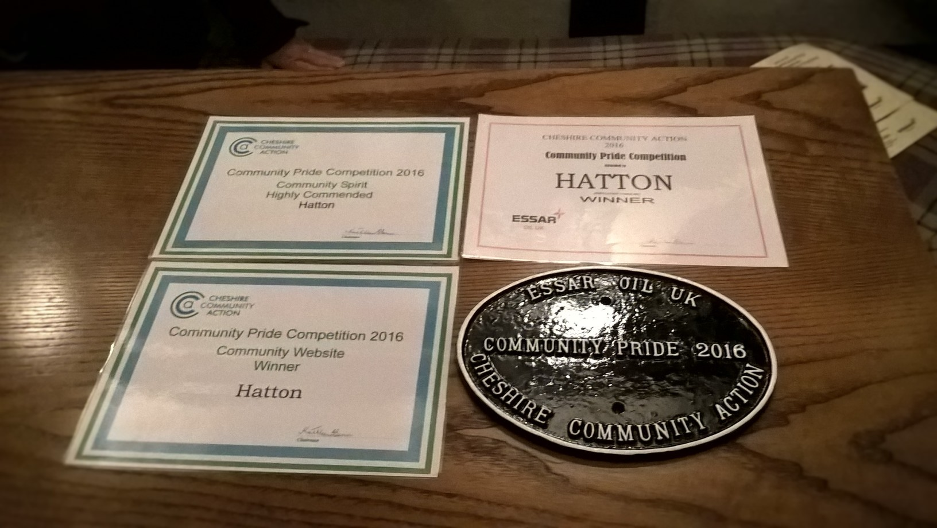



**Good news for Hatton**

**with the new speed**

**restrictions**

and the benefits they can bring for

local residents.

However it has been reported that some motorists are still resisting by tailgating and overtaking creating potential danger for other motorists and pedestrians. It is obvious that the restrictions are going to take some time to become embedded. We are liaising with the police to try to get more police presence and additional signage. PCSO Parr has asked if residents notice cars not adhering to the new limits to contact him with number plate info at [Stephen.parr@cheshire.pnn.police.uk](mailto:Stephen.parr@cheshire.pnn.police.uk) .  
Lets work together to make Hatton roads safer!

*Hatton PC and HVPIG*

Following last year’s fun event Ian and Sylvia are kindly again hosting Hatton’s Halloween Party.

Everyone to meet at Gosling Close Bench at **6pm** for the annual trick or treat trek around Hatton houses.

Parents responsible for their own little monsters please!

After trick or treating it’s back to Branscombe for Hot Dog

and Party Games. Prize for the most terrifying Fancy Dress outfit!

**Hatton residents’ theatre trip to see**

**Dick Whittington**

**and his Amazing Cat**

**HATTON’S HALLOWEEN PARTY Mon 31st Oct**

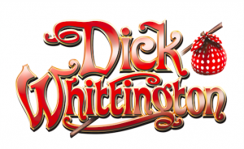

If you have any comments, news, or suggestions you’d like to share with us then email [hattonvillage@gmail.com](mailto:hattonvillage@gmail.com). We’d love to hear from you....!

**HATTON HAPPENINGS**

**Monday 31st October**

Hatton’s **Halloween** Party

**Monday 7th November**

**Hatton Film Club** 7.30 at Hatton Pub & Grill featuring **Elvis meets Nixon**

**Saturday 12th November**

**Local Walk.** Meet Hatton car park 10.30. Please no dogs – cattle in fields

**Saturday 19th November**

**Rail trip to York and Christmas** **Market**. All welcome. If you are interested please ring Ian on 730289

**Monday 21st November**

**Parish Council** **Meeting**.  7.30pm Lewis Carroll Centre Daresbury . All welcome and opportunity for residents to raise any issues from 7.30 to 7.45pm. Minutes and agendas can be found at hattonvillage.co.uk.

**Tuesday 22nd November**

**Residents’ Lunch** at Hatton Pub & Grill. Speaker to be confirmed. Please confirm attendance to Robin by 5.00 pm on Sunday 20th November.

**Saturday 3rd December**

**Liverpool Day trip** see above

**December** – **Carol Singing** Date and details tbc

**Thursday 29th December**

**Dick Whittington** see above

**FEELING LONELY - THERE IS NO NEED TO BE ALONE! - 0800 4 70 80 90**

The SILVER LINE HELPLINE is a national, free and confidential helpline for older people (mostly over 60’s) open 24 hours a day, 7 days a week and 365 days a year. Founded by Dame Esther Rantzen in 2013 they offer information, advice AND friendship through somebody to talk to knowing that your call is treated in the strictest of confidence.

SILVER LINE OFFERS MANY SERVICES INCLUDING:

Telephone Friendship; Silver Letters – a fortnightly exchange of letters; Silver Circles – a call between a group of older people on a shared topic of interest (up to 60 minutes per week)

Silver Line Connects – help with informing and connecting an older person with national and local services

www.thesilverline.org.uk

**Monday 7th November 7.30pm**

**At Hatton Pub**

Featuring

**E L V I S M E E T S N I X O N**

All Hatton residents, friends and families welcome.

Admission free

Newsletter

kindly printed

by



**Hatton’s Day out in Liverpool**

CSA  subsidised Coach Trip for Hatton **ONLY £5**

**Saturday 3rd December leaving Hatton 10.30am** So much to do in this lovely city. Here are some examples:-  
1.**Winter Arts/Craft Fair** in Liverpool Cathedral. Over 200 stalls of the best of Merseyside's artists/makers. Lots of opportunities for Christmas gifts in beautiful surroundings  
2. Britains Real Ale Capital..**Camra City Centre Walk**  
3.**Liverpool One**  
4. **CULTURE** (museums /art galleries) and **COCKTAILS**  in Albert Dock

**JUST DO WHATEVER TAKES YOUR FANCY**

Perhaps end up in the Hatton for a Christmas meal together on our return at 6.00pm?  
Get your tickets from Margaret (730029) or Judith (730509) before 13th November.

**Date**: Thursday 29th December 2016 at 1:30 **Venue**: The Altrincham Garrick Playhouse

**Transport:** Departure time of coach TBA

**Cost:** **£12.50** **for under 16’s**, **£15 for students and over 60’s** and **£17.50 for adults-** Price includes the cost of the coach. Young children must be accompanied by an adult

**Tickets**: **32 places** will be available (limited availability - first come first served)

**Please return payment by Friday 4th November at the latest.**  **After this date we will be unable to book any additional seats*. Please write on back of cheque the type & number of tickets, your name and contact details.*** Cheques made payable to Hatton Village Group. Or download payment slip from hattonvillage.co.uk/news

**Payment can be returned to:** Margaret Winstanley - Hicksons Cottage, Warrington Road; Robin Brocklehurst, Goose Cottage, Goose Lane; Amber Smith, 13 Gosling Close or Liz Wareing, Glenfield, Hatton Lane

**H a t t o n f i l m c l u b**