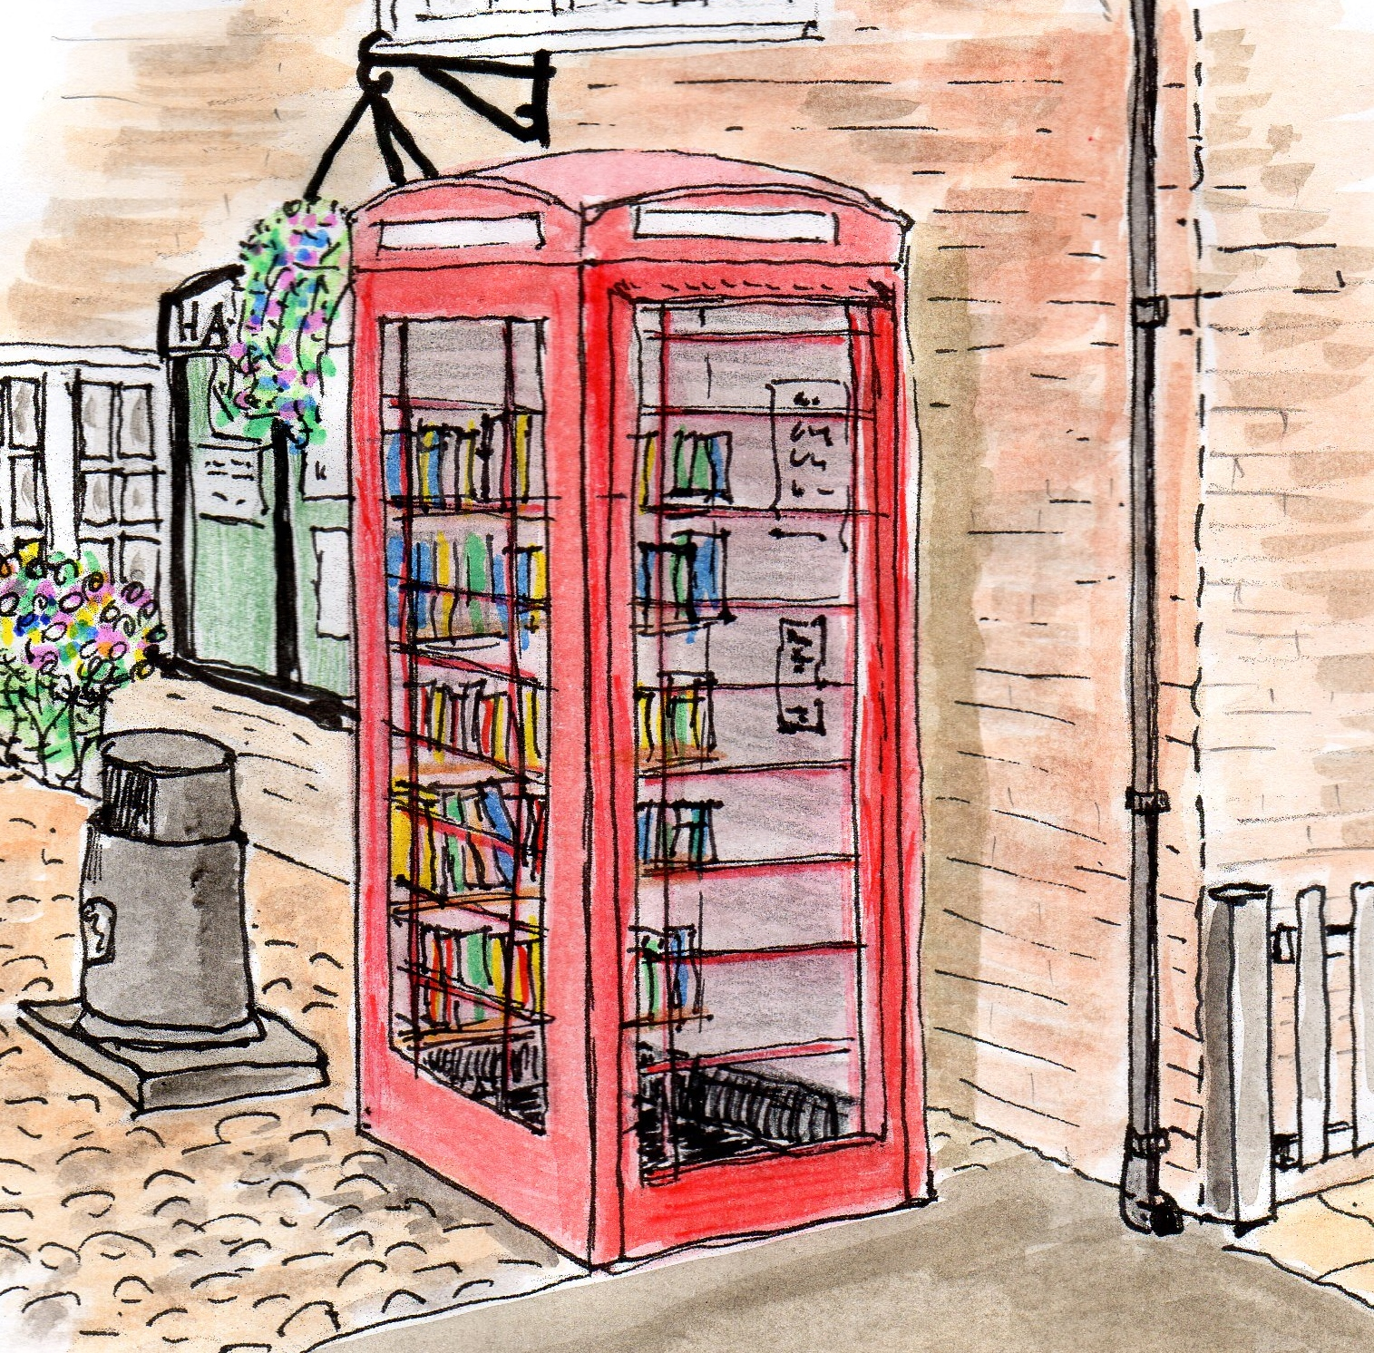

***In your JANUARY newsletter*: Cheshire Life comes to Hatton; Film Club; Hatton Happenings;**

**Christmas Social events; Looking ahead in 2017; Broadband update**

Hatton Life



Email:hattonvillage@gmail.co.uk

www.hattonvillage.co.uk

**Issue No 18 January 2017**



Hatton Hits the Headlines

in this month’s Cheshire Life

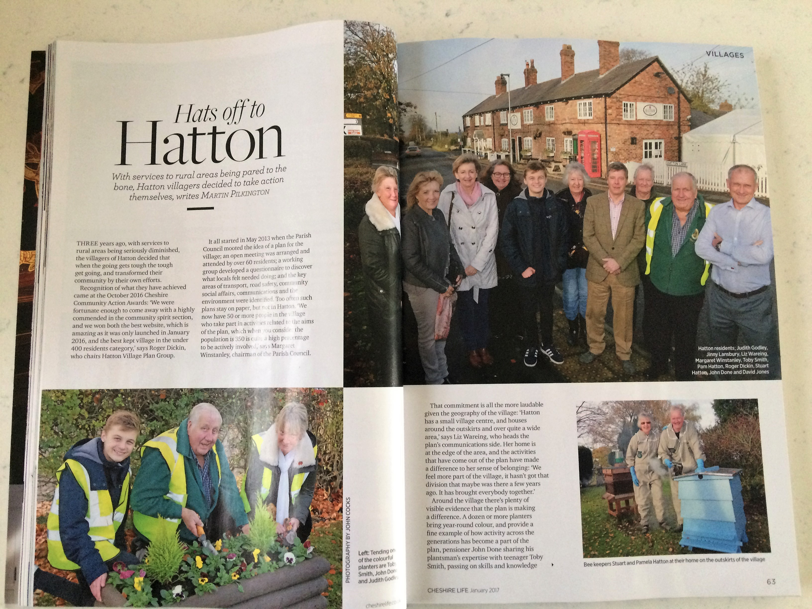

Hatton’s achievements have been acknowledged in this month’s Cheshire Life Magazine, following the presentation of awards for **Best Kept Village** (under 400) and **Best Community Website**.

Read all about it! On sale in newsagents and supermarkets, but only while stocks last

**Carol Singing**

**Broadband Update**

**F I L M C L U B**

We received over 60 responses to the recent **Broadband Questionnaire** which shows significant interest and is quite encouraging. The responses have been collated and the key information sent to the **Community Fibre Partnership** group in BT. This will hopefully show sufficient interest for BT to propose a solution and costs for Hatton via the partnership scheme. The next stage is to await this response and then see if the solution is feasible.

Hattoners, old, new, young and slightly less young, hit the streets for the annual Carol Singing. Singing might be stretching it a bit, but this year there were more of us- about 13 in total, so the sound which came out of us resembled singing.

As usual the **Goose Lane** and **Gosling Close** residents stepped up to the mark and stood, listened and smiled as we forced them to hear just another verse.

One hundred pounds was raised in aid of Care UK – The Rucksack Project, ensuring the homeless of Warrington at least some comfort during Christmas.

**Monday 9th January 2017**

7.30 at

Hatton Pub and Grill

Featuring

**Our Kind of Traitor**

All Hatton’s friends and families welcome

**Admission FREE**

**Ending 2016 with Hatton’s December social events**



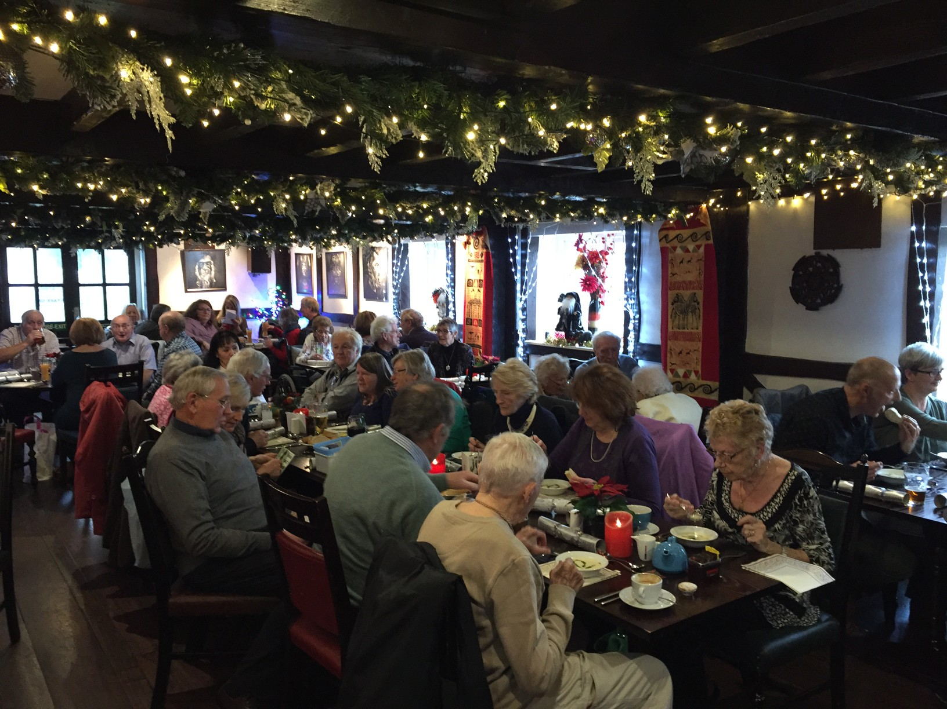

A large group of happy Hattoners had a great day out in Liverpool on December 3rd, visiting shops, markets, galleries, pubs restaurants and much more! Chester is one option for 2017? Any other suggestions then let us know.

If you have any comments, news, or suggestions you’d like to share with us then email [hattonvillage@gmail.com](mailto:hattonvillage@gmail.com). We’d love to hear from you....!

Many of you attended our Open Evening in late September 2016. It was a great opportunity to review our successes and to understand the issues and wishes you wanted us to consider.

I’m delighted to confirm that the Hatton Village Plan Implementation Group has accepted **your** challenges and will be investigating the following from early 2017:

* A Buddy Scheme to offer support and/or possible travel facilities (if appropriate & available)
* Positioning a Defibrillator in the village
* Providing ‘First Responder’ information for those wishing to volunteer
* Expanding the Traders List on the website for trusted local tradespeople
* Raising the need for Grit Box maintenance and enhancement with Warrington BC
* Highlighting village areas which would benefit from additional volunteer planting
* Raising Street-sweeping with WBC
* Reviewing disruption near the recycling area and Sankey Lane
* Pavement along Hatton Lane

***Don’t be shy - get in touch!***

**If you have knowledge of any of the above –**

**or simply wish to volunteer to help –**

**don’t be Shy!!**

**HATTON HAPPENINGS**

**Monday 9th January**

**Hatton Film Club** 7.30 at Hatton Pub & Grill featuring

**Our Kind of Traitor**

**Monday 15th January. Parish Council Meeting**

**Tuesday 16th January**

**Residents’ Lunch**.

**January is a quiet month in the Hatton calendar, whilst we take a breath and start making plans for the year. Don’t worry -The 2017 calendar of events is in the making! If you have a great idea for a Hatton event please share it at** [**hattonvillage@gmail.com**](mailto:hattonvillage@gmail.com) **or better still, join the Community and Social Action Group and help to shape some great events for the whole village in 2017.**

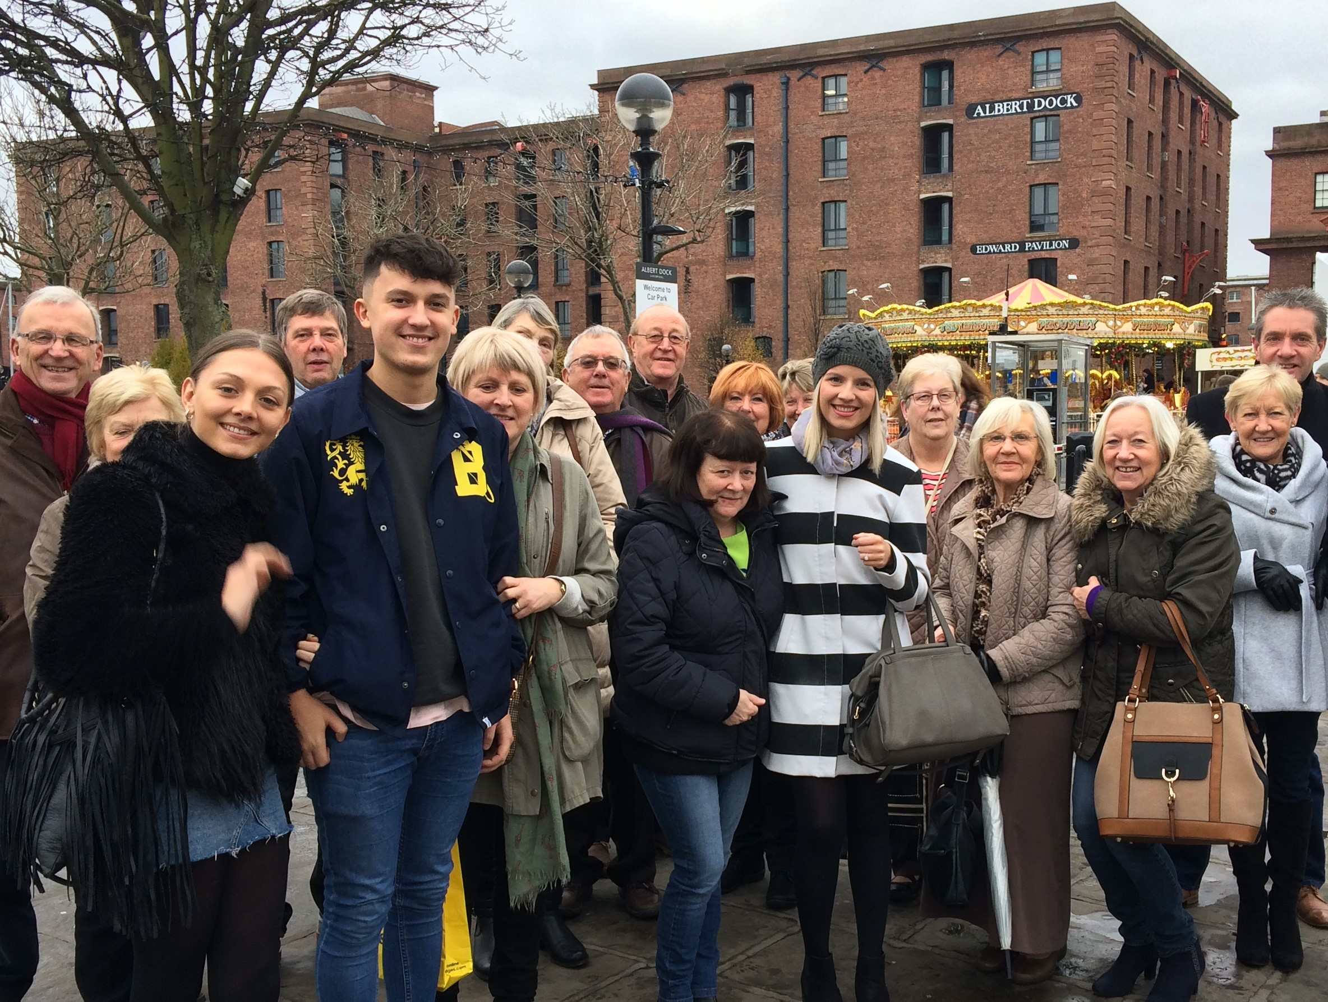

Liverpool December 2016

Christmas really got off to an early start in Hatton with the Residents’ Lunch held at The Hatton on 13th December. Thirty eight residents enjoyed a fabulous Christmas Lunch.

As is always the case at these residents’ lunches the conversation flowed and the laughter was none stop.

Once the food was over the guests were faced with a light hearted Christmas quiz won by Julian and Margaret Wrigley.

Julian then proceeded to demonstrate his prowess as a 'Bingo Caller' for the customary games which brought proceedings to an end.

Hopefully one or two of those who attended will have enjoyed themselves sufficiently to join the regulars for the monthly lunches the next one being on the third Tuesday in January 2017.