***In your April newsletter*: Easter Treasure Hunt; My Favourite...; Hatton Film Club; Litter Pickers; Residents’ Lunch; Lending Library; Sid’s Holiday; Hatton Memories**



Hatton Life



Email:hattonvillage@gmail.co.uk

www.hattonvillage.co.uk

**Issue No 21 April 2017**

The next residents’ lunch will take place on **Wednesday 12th April** starting at the usual time of 12.15pm.

This month we have a surprise speaker!  I hope that it will not turn out to be an unpleasant surprise!

The speaker's subject will be "**The History of the Lancashire Cotton Industry".**

As I write this the transfer of 'The Hatton' to the new owners has not yet  taken place but I am assured by Gina that the lunch will definitely go ahead.

Please will you advise Robin on 730030 if you are attending by Sunday evening the 9th April.

**RESIDENTS’ LUNCH**

**TELEPHONE BOX LENDING LIBRARY**

Eagle eyed villagers will have noticed that our telephone box has been repaired and painted. Many thanks to Julian Wrigley and Stuart Tranter who undertook the work on our behalf.

It looks great and helps maintain this much photographed amenity.

The lending library has been cleared and cleaned, and is looking more

inviting than it has in recent months.

Please help us to maintain it in its

current state by only placing one or two books in it when you take out a book.

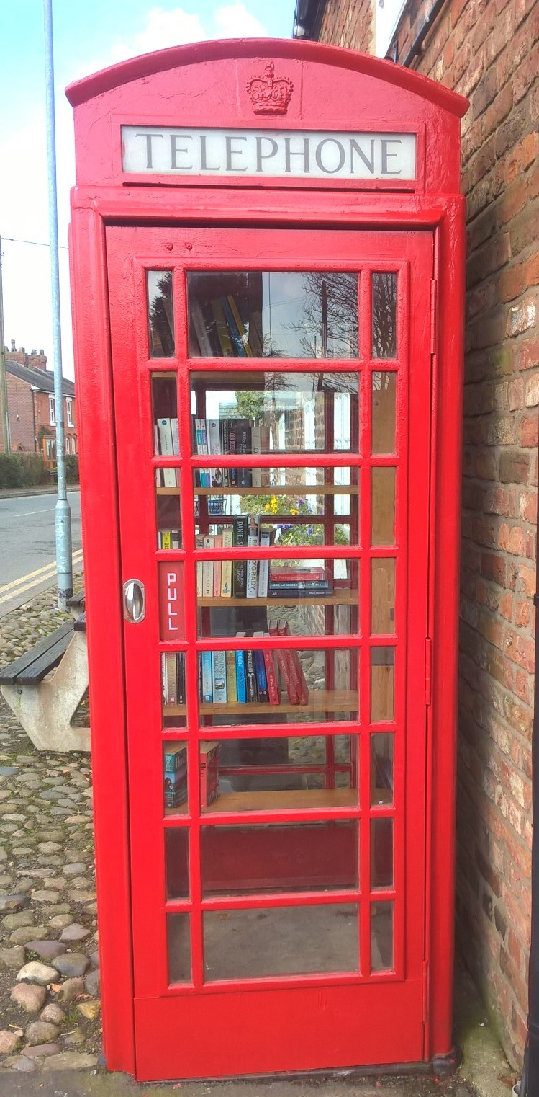

If you have a number of unwanted books please take them to your local charity shop.

Thank you for your support

**MEMORIES OF HATTON**

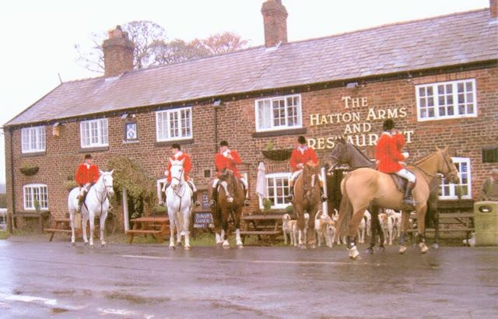

**Easter Treasure Hunt Sat 1st April at 2.00pm**

We have had lots of animals offered for this year’s exciting Hunt – we would love some more homes to come forward!

If you are happy to help please let us know, you do not have to be in on the day as we will arrange to place and remove the toy animals on the afternoon.



We would like to see any old photographs of Hatton that you may have. We would like to start   an archive and the new management at The Hatton would like to display some in the pub too.

Please email a copy to hattonvillage@gmail.com with any details you have about the photograph. If you have problems emailing please contact Margaret on 07947 137 349.

The meeting time for the Easter Hunt is 2.00pm in the Hatton Pub Garden, where you will collect your all-important tick-sheets. Any volunteers to help set up etc from approx. 1.45 would be very welcome

For any offers or questions about the day please email [angeladickin@hotmail.co.uk](mailto:angeladickin@hotmail.co.uk)

**A LITTER FREE VILLAGE**



**BRIDGE OF SPIES**

**Showing at**

**HATTON FILM CLUB**

**Monday 3rd April 7.30 at Hatton Pub**

**EVERYONE WELCOME Admission is FREE...!**

If it ever stops raining I am sure we will all be able to enjoy Spring in our lovely village. It would be a great help to our regular team of litter pickers if all villagers could keep a check on the frontage of their properties and remove any litter. We can never stop those people driving through our village who think it is OK to throw litter out of their car windows, but together we can keep our environment looking good for all to enjoy.

**SUNFLOWER COMPETITION**

The sunflowers have been sown & some have popped up already. This year’s competition is open to both adults & children. Ian will advise when they are ready for collection.

**HATTON HAPPENINGS**

**MY FAVOURITE....**

This month’s ‘My Favourite...’ comes from

Margaret Winstanley.

‘My beautiful Camellia....comes into flower Feb/March in my garden and provides a splash of colour at a dull time of year reminding me of what's to come

in the Spring and Summer.’

**Saturday April 1st**– **Easter Treasure Hunt**

**Monday 3rd April Hatton Film Club** 7.30 at Hatton Pub featuring **BRIDGE OF SPIES**

**Wednesday 12th April - Residents’ Lunch 12.30** Hatton Pub

**May** – **Sunflower Seed** collection ready for the competing in the Hugest Sunflower

**June 17th**– **Hatton’s FUN DAY Great Big Get Together** and launch of **Hatton Hat Trail**

**August** – Announcement of winners **of Sunflower Competition and Hat Trail**

**October** – **Halloween Horrors**

**November** – **Hatton’s Christmas Coach Trip**

**December** – **Carol Singing**

If you’d like to be involved in any way what so ever, please do get in touch. There are lots of little jobs going on in the background which could really do with your help



Newsletter kindly printed by

**Urban Building Projects Ltd**

We hope we made Sid happy to be in Hatton and kept to 30mph on Hatton Lane.

Thanks to Stretton PC for letting us use him ☺



Sid has been on his holiday

He had a Hatton Holiday for a week and spent it on Hatton Lane

Police Cadet **Toby Smith** has chosen to do his voluntary work in Hatton. Toby and his dad Andy, spent a whole day bringing the path in Hatton back to its former glory! Great job well done! The pathway and daffodils in Hatton look beautiful after all their hard work.

