***In your March newsletter*: Poop free village; Creamfields; Hatton’s Film Club; Residents’ Lunch; Mystery Kitty; Easter Hunt; Hatton Diary; Your favourite place**



Hatton Life



Email:hattonvillage@gmail.co.uk

www.hattonvillage.co.uk

**Issue No 20 March 2017**

**CREAMFIELDS 2017**

Hatton Parish Council have organised a Creamfields Working Group. The idea of the group is to meet bi-monthly with Creamfields and work together on ideas to help our communities. Each of the local villages has representatives. The first meeting was on Friday 24th February.

**CREAMFIELDS NEED TO KNOW!**

Residents will be provided with transport to/from Hatton and North Entrance. A couple of minibuses morning and night will run.  
What time would you want  these minibuses to run to/from North Entrance and Hatton?

Ideas/requests /preferences on any matter to [mwinstanley21@gmail.com](mailto:mwinstanley21@gmail.com).

Hello to all Hatton hounds. We hope you really enjoy living in our lovely village and have fun on all your walks. We would like you to ask all the humans that take care of you on a day to day basis to ensure that they clean up after you do what comes natural. Recently, a number of residents have been concerned with the increase in 'doggie do' being left on our pavements, in the road and on paths. We want you to stay fit and healthy, and would ask that all owners clean up fully after their dogs and take bags home to dispose of appropriately.

**C A L L I N G**

**A L L**

**H A T T O N**

**H O U N D S**



**Easter Treasure Hunt Sat 1st April at 2.00pm**

Our second annual Easter Treasure Hunt for children aged up to 11yrs is being planned!

It will be in and around Goose Lane and Gosling Close, with Easter prizes up for grabs!

The plan is to meet in the pub garden for 2.00pm and then regroup there for the prize-giving at 3pm.

As last year, the children will be given a list of ‘Easter-themed’ objects to find, which will be visible from the pavements. We want to keep the children – and your gardens – as safe as possible

and so we are asking for your help.

We are looking for residents who would be willing for us to place an object i.e. a fluffy rabbit, in their gardens so it can be seen from the roadside. Of course, if you already have an item you could use i.e. a garden ornament, then that would be even better!

If you took part last year – many thanks. We are hoping you may yet have another hiding place we could use . . . . .



If you would like to help give our younger residents a fun-packed afternoon, please let us know by the 20th March, so we can plan the route and prepare the all-important Tick Sheets.

To get in touch please email [hattonvillage@gmail.com](mailto:hattonvillage@gmail.com) (putting ‘Easter TH’ in the subject box) by 20th March

or call Roger on 07871 544500

Thank you, Angela & Roger Dickin

**MYSTERY CAT**

Does anyone on Goose Lane or Gosling Close recognise this little chap (or chapess)?  
A Goose Lane resident had befriended him/her for the last few months but hasn't had a visit since 11th Feb and are keen to know all is well. Kitty walks with a bit of restriction in the hips and is collarless.

Please email [hattonvillage@gmail.com](mailto:hattonvillage@gmail.com) if you have any information.

**MARCH RESIDENTS’ LUNCH**

After February's very successful lunch we are looking forward to The March lunch.

Due to the clash with the Cheltenham Festival, Mark and Gina have asked that we change the date.

**The lunch will now take place on**

**Wednesday 8th March.**

We are sorry for the change from our normal date.

Confirm attendance to Robin by Sunday 5th March please.

**Absolutely**

**Fabulous**

Monday 6th March

7.30 at

Hatton Pub



**HATTON FILM CLUB**

**Do you have a favourite**

**place in your village?**

**Next month we are launching a regular item for the newsletter and the website featuring a photo of what makes Hatton special for you.**

It could be a special plant in your garden, and field that you enjoy walking through, the Library, the Pub, some architecture, livestock or a tree which is particularly pretty at a certain time of year.

All you need to do is send the photo (at least 1mb please) and description of your favourite part of Hatton to [hattonvillage@gmail.com](mailto:hattonvillage@gmail.com) and it will be featured in a subsequent newsletter, on the website and on our social media pages.

**HATTON HAPPENINGS**

**Monday 6th March Hatton Film Club** 7.30 at Hatton Pub featuring **ABSOLUTELY FABULOUS – THE MOVIE**

**Wednesday 8th March. Residents’ Lunch 12.30** Hatton Pub

**April 1st**– **Easter Treasure Hunt**

**May** – **Sunflower Seed** collection ready for the competing in the Hugest Sunflower

**June 17th**– **Hatton’s FUN DAY Great Big Get Together** and launch of **Hatton Hat Trail**

**August** – Announcement of winners **of Sunflower Competition and Hat Trail**

**October** – **Halloween Horrors**

**November** – **Hatton’s Christmas Coach Trip**

**December** – **Carol Singing**

If you’d like to be involved in any way what so ever, please do get in touch. There are lots of little jobs going on in the background which could really do with your help



Newsletter

kindly printed by

**Urban Building**

**Projects Ltd**

**EVERYONE WELCOME**

**Admission is FREE...!**

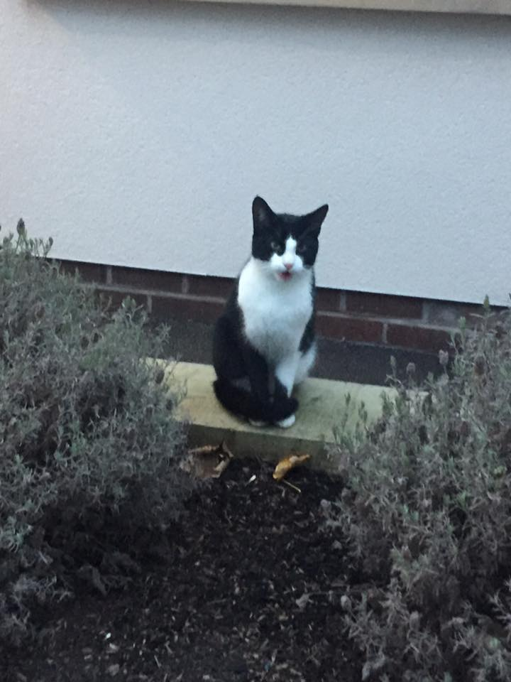

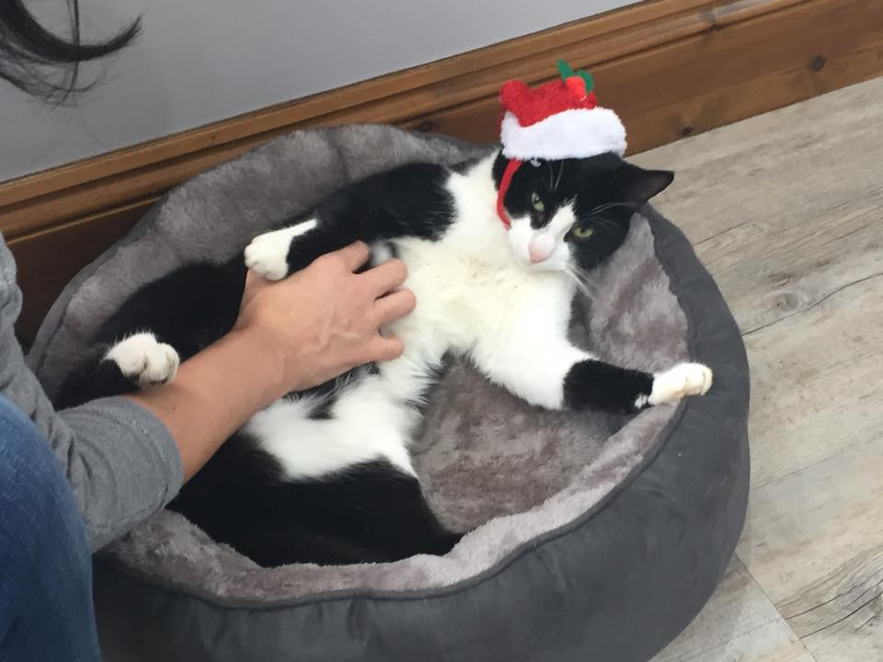

**PARISH COUNCIL NEWS**

Want to help your local community?

We hope to build up a list of caring individuals who are prepared to offer support to local people who may need some help occasionally, perhaps help with shopping or even just have a cup of tea and a chat occasionally.

Is there anyone who is willing to co-ordinate a casual local lift scheme in the village?



Could you join a rota to keep Hatton’s **unique Library** AKA Phone box tidy? It’s soon going to be painted and then sorted and will then need to be kept organised and tidy.

