***In your May newsletter*: Hats On Festival; Fun Day; Film Club; Environment News; Sunflower competition; Diary Dates; Speed restrictions; Bus Stop Surprise**



Hatton Life



Email:hattonvillage@gmail.co.uk

www.hattonvillage.co.uk

**Issue No 22 May 2017**

**The 2017 Hats On Festival**

**It’s that time again, get your thinking caps on and create a hat to join in the fun!**

This year’s Hat Hunt promises to be even bigger- to complement our own residents’ creations, we have invited St Matthews Primary School to take part and their entries will be judged at the Fun Day!

So as well as letting your imagination run wild with your own designs, we will be looking for homes across the village for their winning hats!

The Hats On Festival will start soon after the Fun Day – what you will be displaying for the Hunters to find this year?

**TRANSPORT AND ROAD SAFETY UPDATE**

The number one concern raised by Hatton residents in the 2015 Village Questionnaire was traffic speeding through our village.

The **Village Implementation Group** and **Parish Council** have worked diligently in this area, securing speed limits reductions in 4 areas of the village and a weight restriction reducing the volume of Heavy Commercial Vehicles through Hatton.

As getting drivers to change their behaviours doesn’t happen overnight, we know more needs to be done to enforce the new speed limits and reduce tailgating on Hatton

We are working with the **Police, Warrington Borough Council** and other bodies to implement further improvements; current Highways Regulations do not allow for repeater signs or road painting.

**PCSO Stephen Parr** has undertaken formal speed enforcement on Hatton Lane on at least 2 occasions this year. **20 vehicles** were caught exceeding the 30mph and received the appropriate penalties and only last week **21 drivers** speeding towards Stretton, with the fastest driver travelling at **55mph in a 30mph limit**.

**Stretton PC** kindly loaned us their “Smiley Face” speed sign for 1 week and our thanks go to them for their generosity. The statistics gathered by residents detailed 57% of vehicles travelling at +36mph and 10% travelling at +46mph. Thanks go to Liz Wareing, Judith Godley and Kathy Merrett for giving up their personal time. These statistics have been shared with the Police to make the case for further formal enforcement.

Other options we are exploring include a **Community Speed Gun** operated by residents and a more visible ‘**entrance**’ to the village

Our case can only be helped by reporting dangerous driving and speeding to the appropriate authorities so please report instances to our PCSO Stephen Parr [Stephen.parr@cheshire.pnn.police.uk](mailto:Stephen.parr@cheshire.pnn.police.uk)

If you wish to help improve your village in respect of speeding (formally or informally) please register your interest at [clerk@hattonpccheshire.org.uk](mailto:clerk@hattonpccheshire.org.uk)

**Margaret Winstanley and Roger Dickin** on behalf of Hatton PC and HVPIG



**HATTON 'BIG GET TOGETHER' FUN DAY –**

**JUNE 17TH**

Lots of fun to be had! Bring your family and friends and have a great afternoon in The Hatton Arms garden while raising money for **Air Ambulance and Village Projects**.

**Tombola** - donations to Collette and Janet at 17 Gosling Close.

**Bottles** for ‘**Barrow of Bottles’** raffle prize to Margaret at Hicksons Cottage  
Contact Angela (in advance) on 07887 561080 if **baking** for the cake stall please.  
**Children's Hatton Hat Festival**...let Margaret know on 07947 137 349 if your child will be entering the competition. Hats will be judged on the day.  
**Social Media Stall** - learn how to keep in touch with what's going on via your phone.

**GAMES GALORE AND MUCH MUCH MORE!**

**Once again we are asking for your donations for the Fun Day Cake Stall.**

A lot of preparation goes into the stall each year, so if you are intending to donate any baking this year, it would be really appreciated if you could confirm to Angela what and how many of it you are planning to bake!!

**Could you let us have your pledge by the 1st of June** as that will allow sufficient time to ensure all the usual favourites are on show! **Thank You**

**Mobile 07871 544500**

**or via**

**hattonvillage@gmail.com**





Monday 8th May

**Hatton Film Club**

Featuring

Hatton Pub & Grill 7.30pm

Everyone Welcome

**It’s free and a lot nearer than Warrington or Runcorn and the beer is better! (Not included )**

**NEWS FROM THE ENVIRONMENT TEAM**

A number of maintenance issues have been raised with WBC that resulted in visits from the road washer and gully cleaner. The **Pillmoss Lane road sign** was replaced and anti dog fouling signs have been placed on some lamp posts.

Many thanks go to Andy Smith, Dave Ditchfield and Wilson Lamb for their extensive work to keep the verges in the centre of the village trim and attractive for the benefit of all. The daffodils grew well on the Common in their second year and we will look to undertake some in-fill next year to enhance the display.

Following the repainting of the **telephone box** by Julian Wrigley and Stuart Tranter, 3 villagers have volunteered to keep the inside tidy and remove any books that are in poor condition. Thank you. There is also a **Dog Poo Bag** dispenser, for anyone out walking their dog who is caught short!

Richard Roseby has been very active enhancing the look of the village, **seeding the grass** opposite the pub; **varnishing** all the **benches**; made a **new planter with attached litter bin** situated by bench on bend; and **repaired** the old **PC Notice** **Board** and placed in the bus shelter. Thank you Richard for all your positive work. This notice board will display historical information and photos; local walks and interesting factual items relating to current and past village happenings. Any item displayed will be of ongoing interest and will not become dated.

We now have 11 people regularly on **litter patrols**. They know who they are - many, many thanks.

The biggest job to come is the **summer planting** of all our **tubs**. They will need emptying, preparing with some fresh compost and then planting. Hopefully, this will be complete during the third week in May, weather permitting. When the flowers in the tubs become established we hope they will be enjoyed by all well into Autumn.



Without wishing to embarrass, particular thanks to Richard for the amazing job.

Louise Weir (Hilda's daughter) a renowned illustrator, born and bred in Hatton, has kindly agreed to put something together of her work with poems and a map highlighting her representations. eg Robin's field, the well at Hatton Arms,  Bluebell wood etc. In the meantime we can display of old photographs of Hatton. If you have any then please add them.

If you happen to be meandering down Sankey Lane you’ll notice the new addition in the bus stop.

Thanks go to many for their involvement in its removal, renovation and erection.

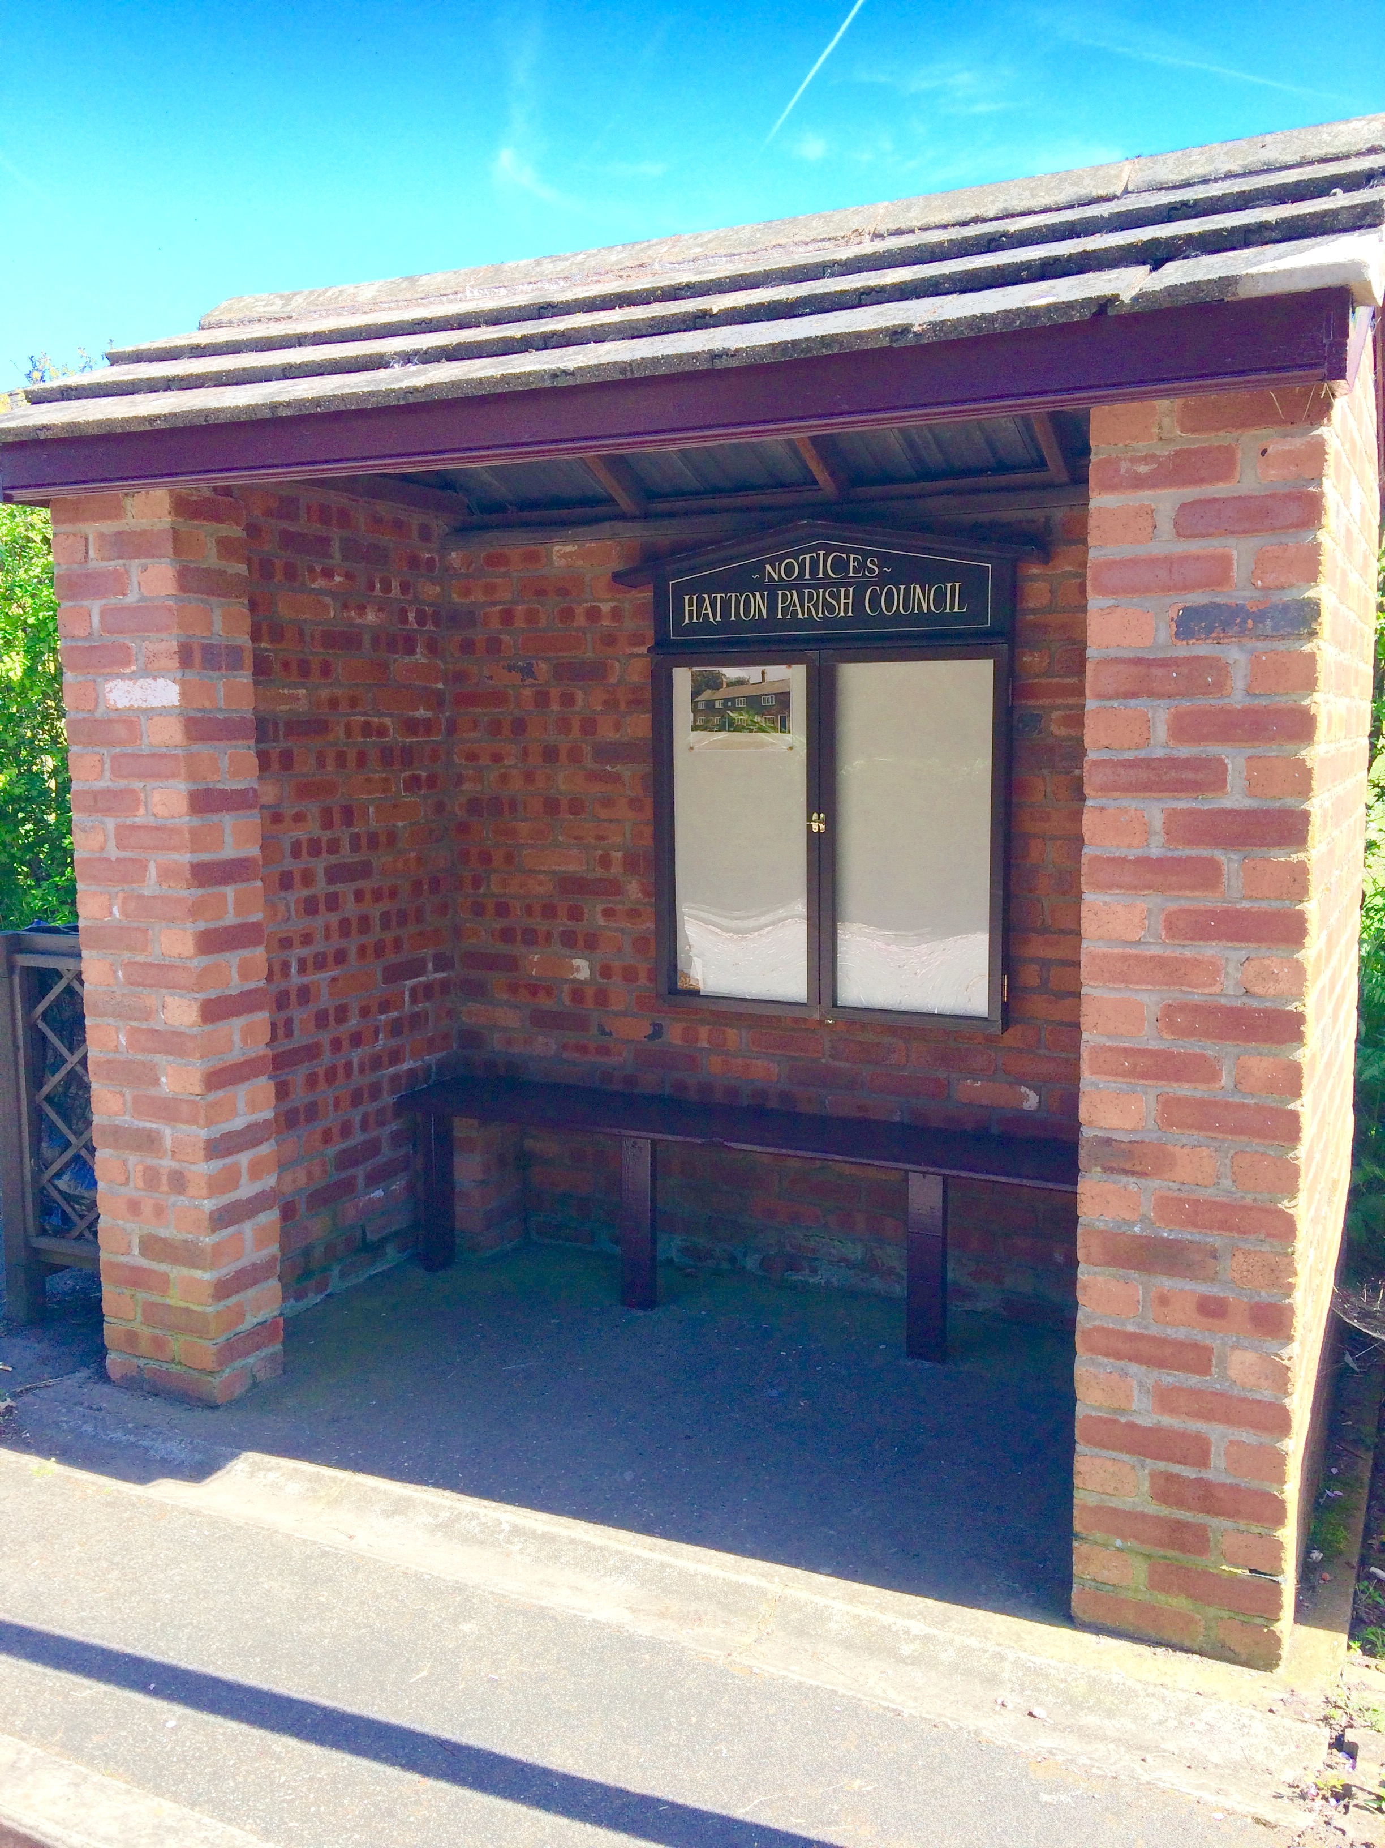

**New amenity for**

**Sankey Lane**

**SUNFLOWER COMPETITION**

Sunflower plants are ready

to collect from Ian & Sylvia,

Branscombe, Warrington Rd

Tel 01925 730289

This is open to children AND adults!

For judging please leave name,

address & tel number.

**HATTON HAPPENINGS**



**Monday 8th May Hatton Film Club** 7.30 at Hatton Pubfeaturing **THE GIRL ON THE TRAIN**

**Tuesday 16th May - Resident's Lunch at** 12.30.

The new pub owners will be in place by then and will be talking about future lunch events with Robin as soon as they are able.

Please advise Robin if you are attending by 5.00pm on Sunday14th May.

**May** – **Sunflower Seed** collection ready for the competing in the Hugest Sunflower

**June 17th**– **Hatton’s FUN DAY Great Big Get Together** and launch of **Hatton Hat Festival**

**August** – Announcement of winners **of Sunflower Competition and Hat Festival Trail**

**October** – **Halloween Horrors**

**November** – **Hatton’s Christmas Coach Trip**

**December** – **Carol Singing**

There’s always a lot going on in the background so if you’d like to get involved be get in touch. You’d be made most welcome!



Newsletter kindly printed by

**Urban Building Projects Ltd**